# Objectives:

Here you will list the anticipated benefits of the ETL mechanisms. ETL processes

are used in many areas in addition to cleansing and importing data into the data

warehouse. You are expected to research and document its importance to large

computer environments where the daily processes depend on the overnight data

cleansing processes

Each “time for action” section:

Summarize the steps and provide the screen shots of the intermediate processes

and summarize the result

Time for action – creating

# Time for action – creating your first SSIS project

In this project, we will create a SSIS package using SQL Server Data Tools (SSDT) for Integration Services. Shown below are the steps we took to create the SSIS project:

1. Open SSDT/Visual Studio and select Business Intelligence > Integration Services Project under New Project.

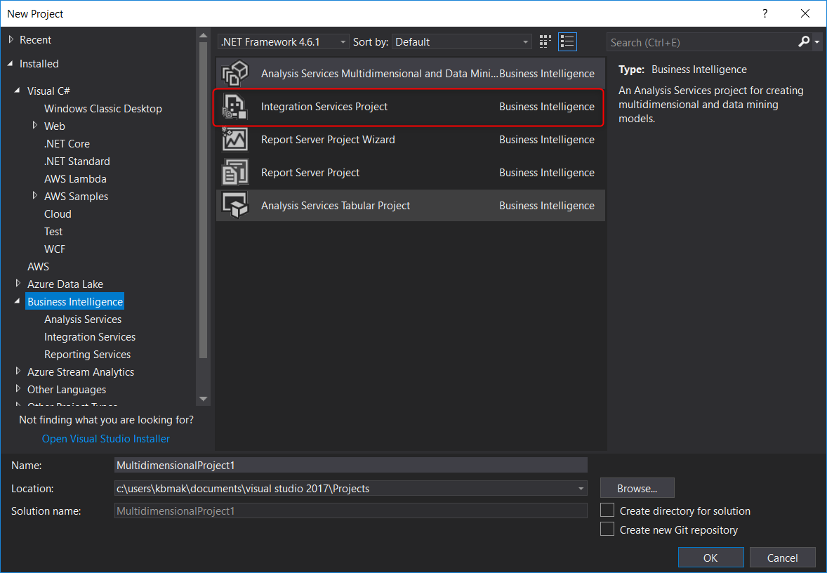

1. That’s it! Now we will have access to the Solution Explorer, Package Designer, and SSIS toolbox.

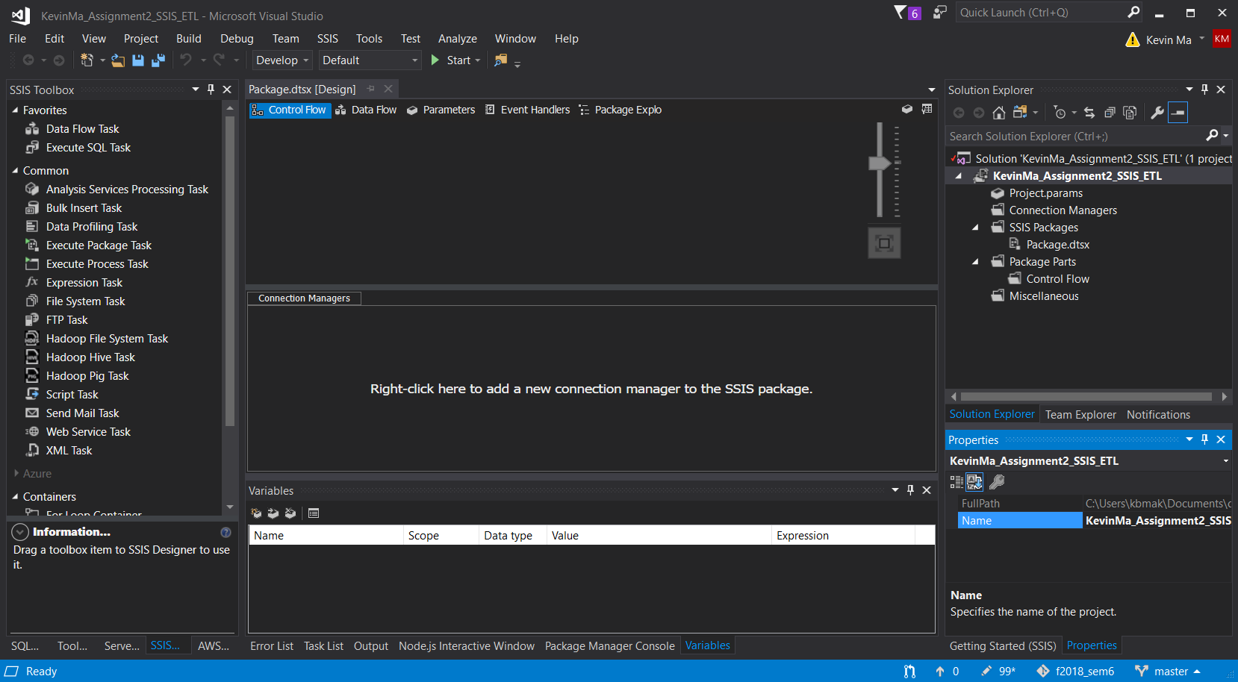

## What did we learn

Here we learned how to create Integration Services Project. We noticed there are different components here than what we saw from our previous lab when we created the Analysis Services Project:

* **Package Designer**: In the preceding screenshot, the package designer shows the Control Flow button.
* **Solution Explorer**: The SSIS projects contain three folders. **SSIS Packages** is used as a location for SSIS package files. **Connection Managers** is used for the project's shared connection managers, which are accessible from all packages in this project. **Miscellaneous** is used for storing any related file, such as documents, to this project and **Project Parameters**, which we will discuss in the following sections.
* **SSIS Toolbox**: This toolbox can be different if the package designer is in Dataflow. The preceding screenshot shows **SSIS Toolbox** for **Control Flow**. This toolbox shows built-in tasks and components that we can drag-and-drop or double-click to add them into the package.
* **Information box**: This tab provides more information about each selected item in the toolbox.
* **Connection Managers**: This tab is used as a location for the package's connection managers. Connection managers of a package can be used only in that package, and other packages cannot access it. Connections to different data sources can be made using connection managers such as OLE DB, ODBC, flat file, and so on.
* **Variables**: The local variables of the package can be managed in this tab.
* **Properties**: This is the default window in SSDT that provides the listed properties of the selected object (such as a package, task, container, and so on) for the developer to view and change the property's values

# Time for action – working with Control Flow tasks

The flow of the execution in the SSIS package will be organized in the **Control Flow** tab. **Control Flow** is the location where we add tasks (to do an operation) and **Containers** (containers of the tasks) and set the order of execution with **Precedence Constraint**.

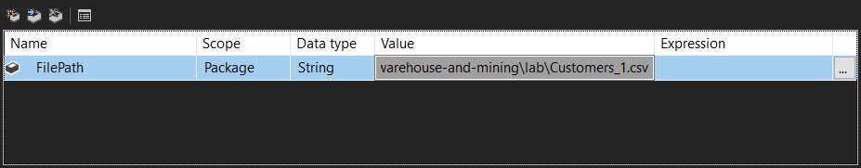

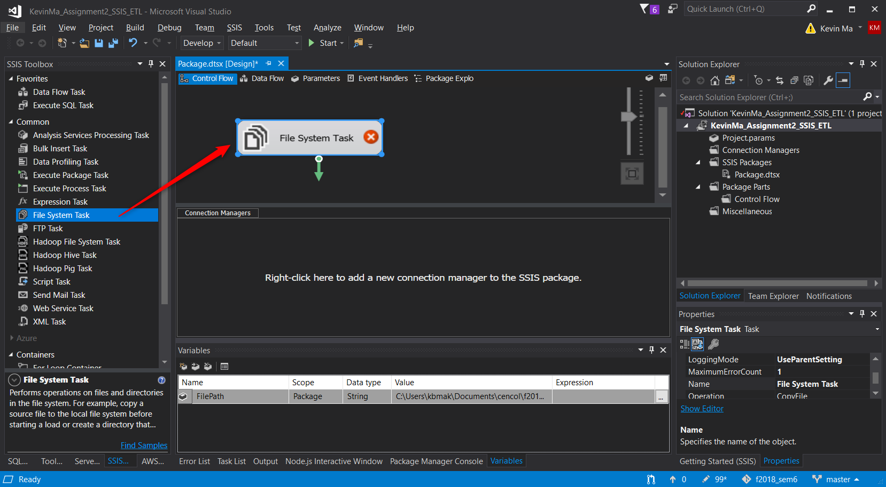

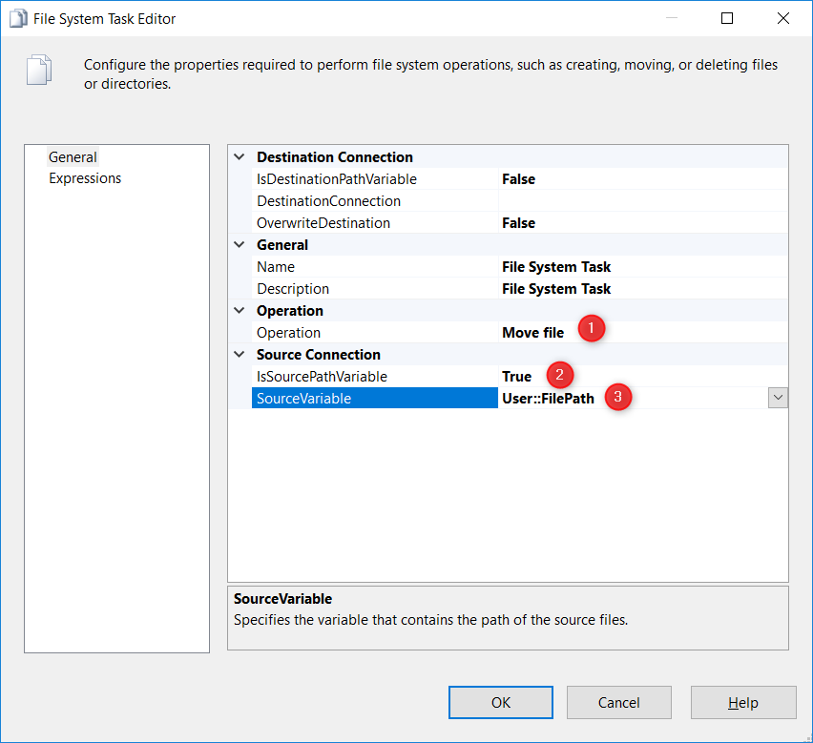

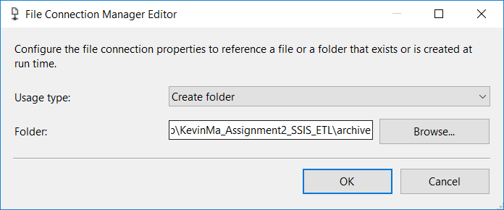

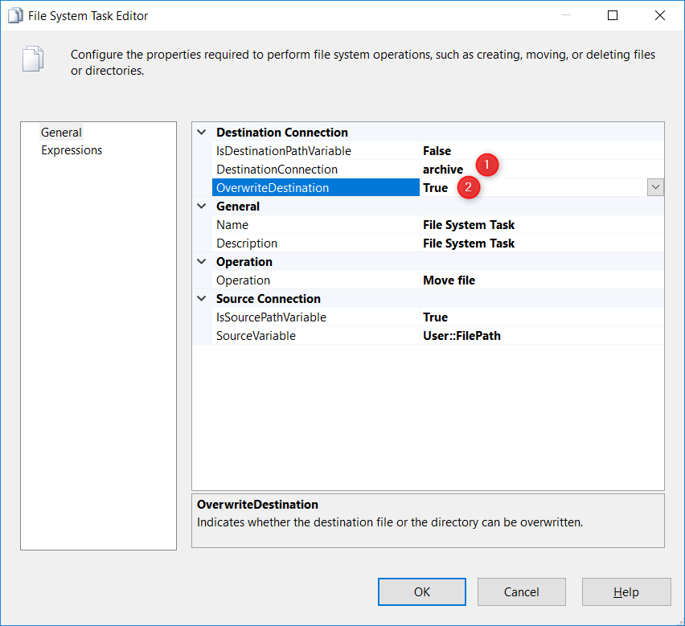

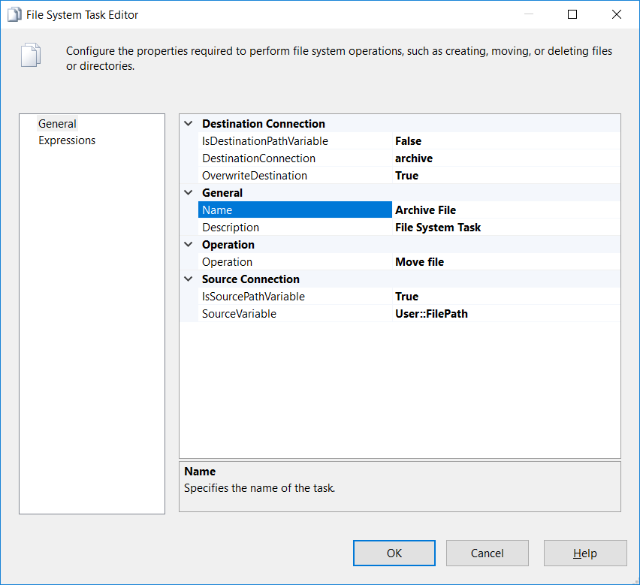

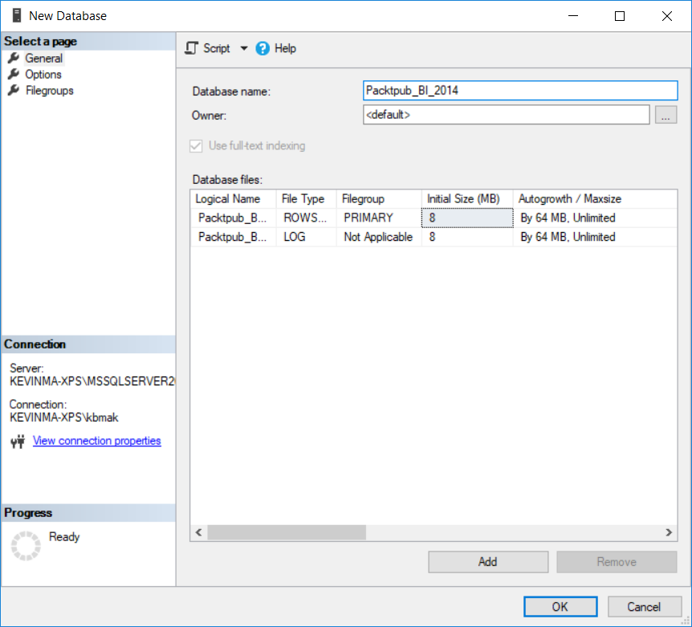

Confusing because instructions skipped step to create database.

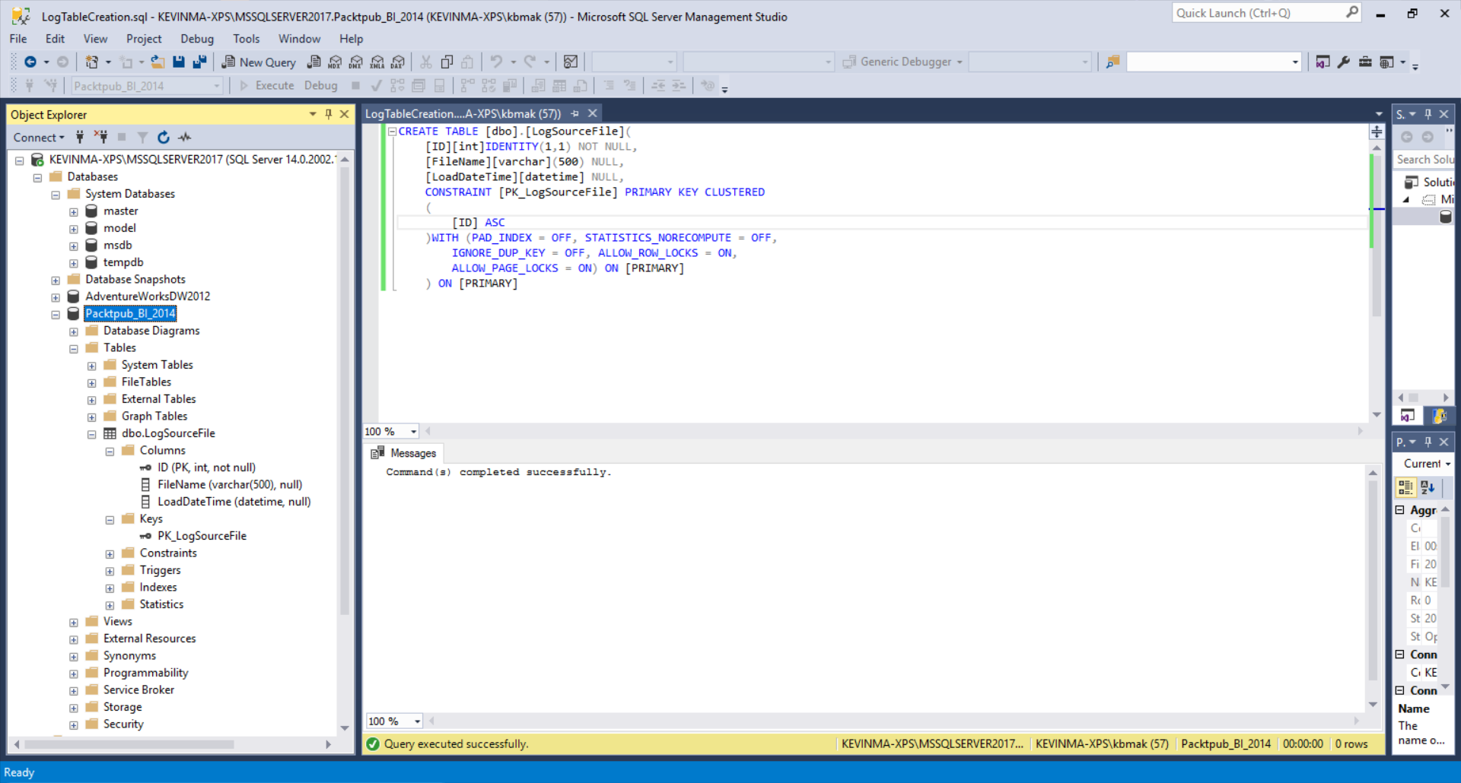

CREATE TABLE [dbo].[LogSourceFile](

[ID][int]IDENTITY(1,1) NOT NULL,

[FileName][varchar](500) NULL,

[LoadDateTime][datetime] NULL,

CONSTRAINT [PK_LogSourceFile] PRIMARY KEY CLUSTERED

(

[ID] ASC

)WITH (PAD_INDEX = OFF, STATISTICS_NORECOMPUTE = OFF,

IGNORE_DUP_KEY = OFF, ALLOW_ROW_LOCKS = ON,

ALLOW_PAGE_LOCKS = ON) ON [PRIMARY]

) ON [PRIMARY]

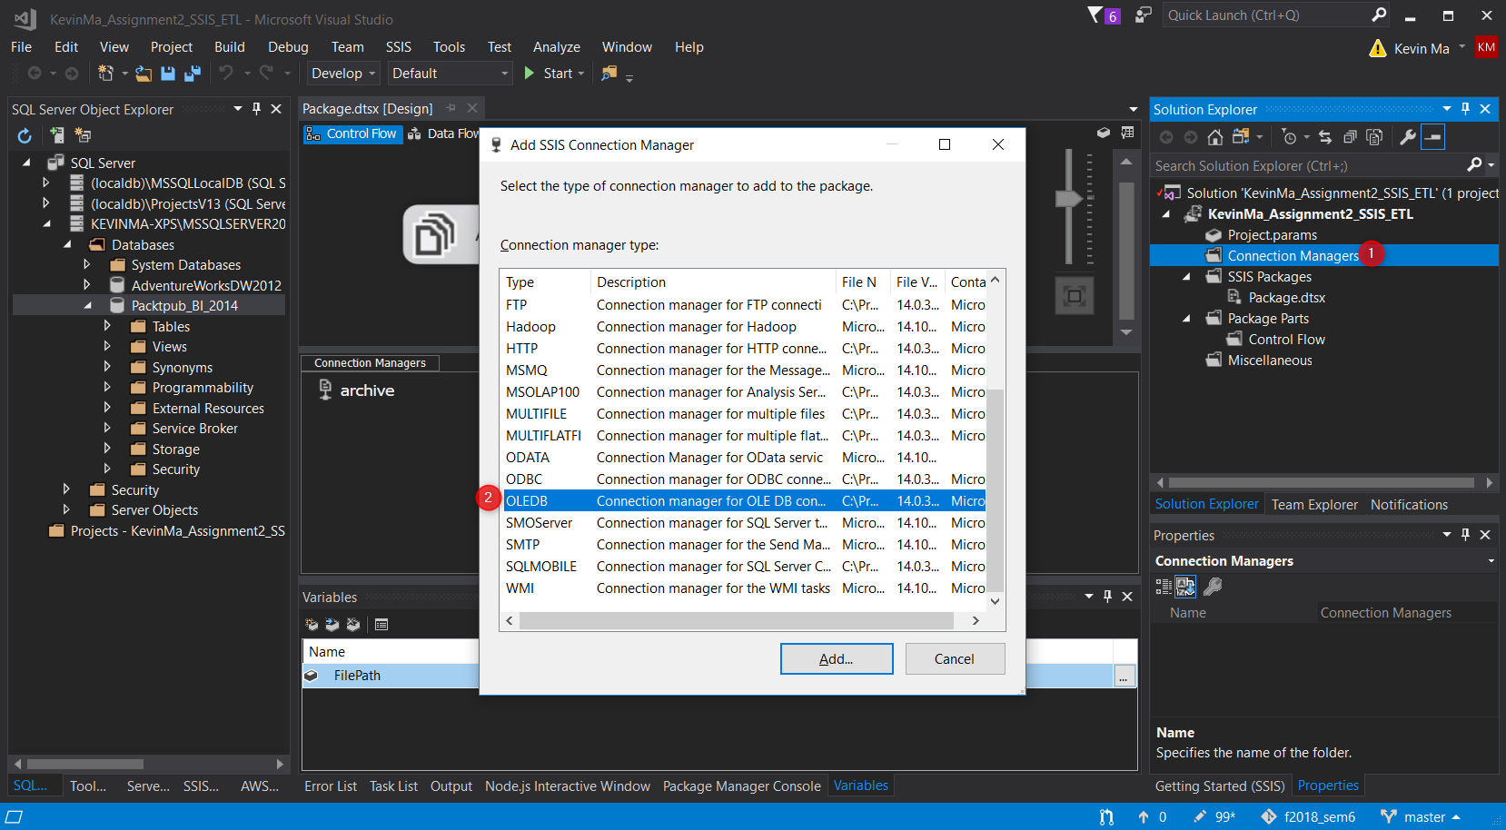

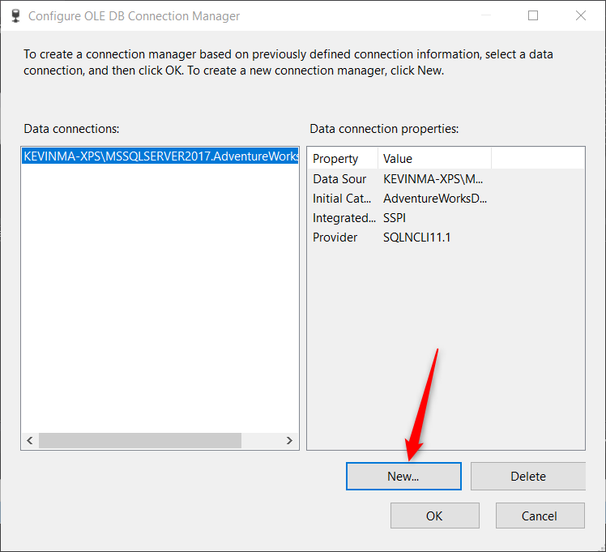

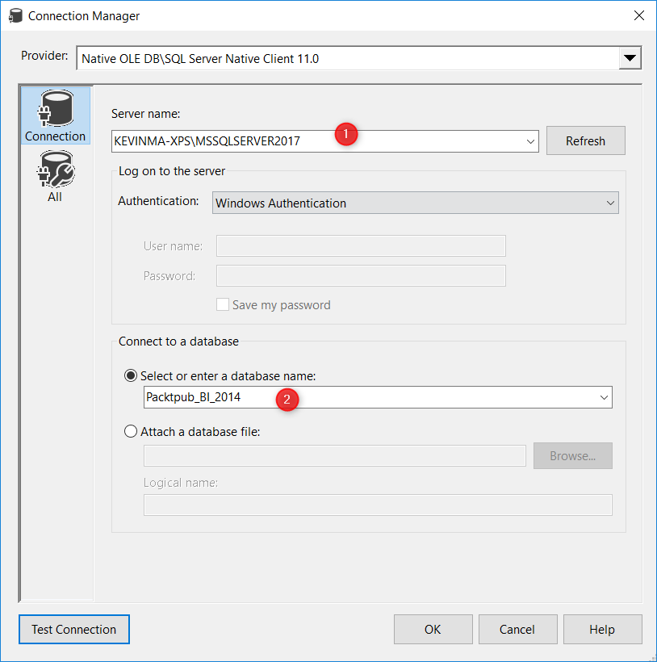

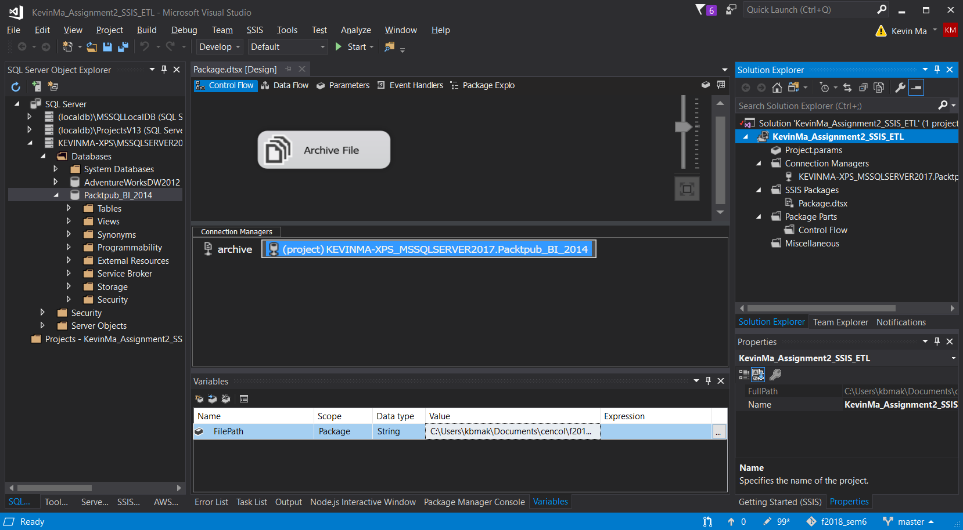

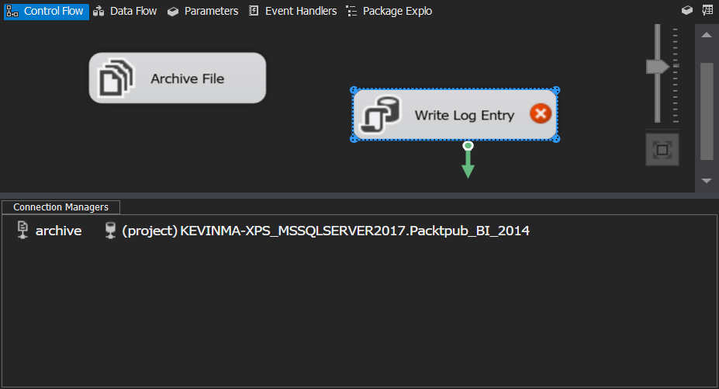

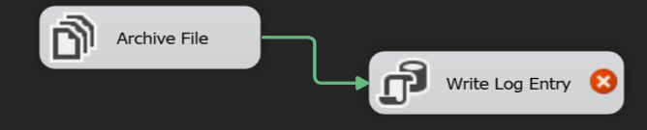

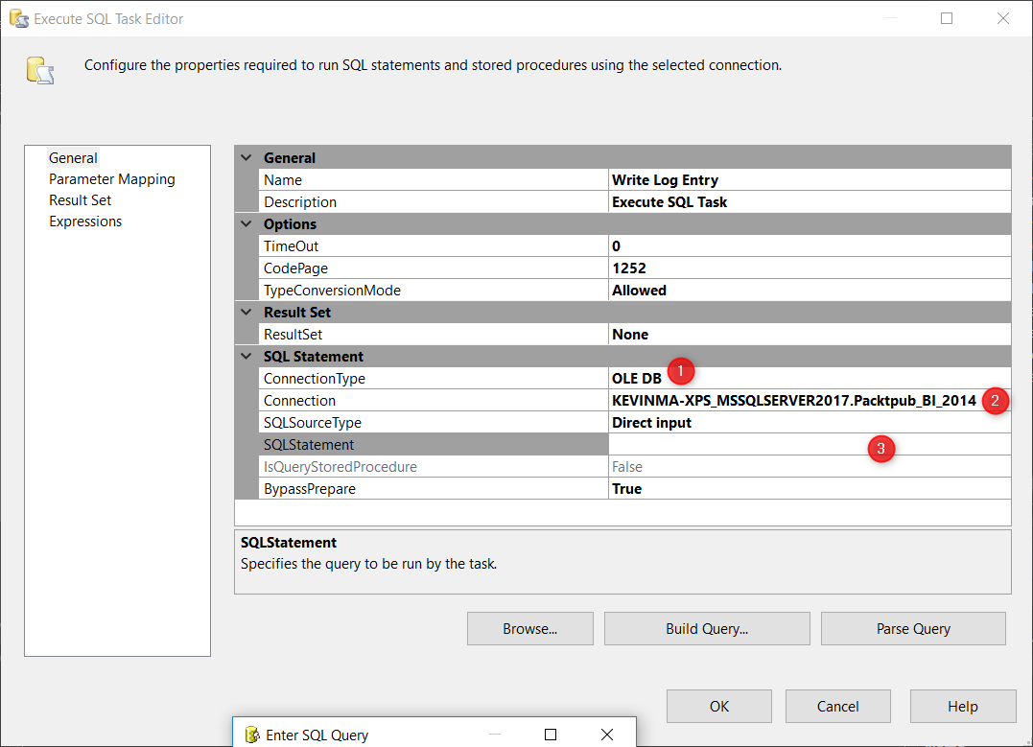

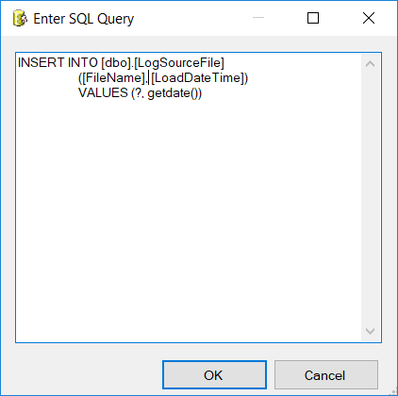

INSERT INTO [dbo].[LogSourceFile]

([FileName], [LoadDateTime])

VALUES (?, getdate())

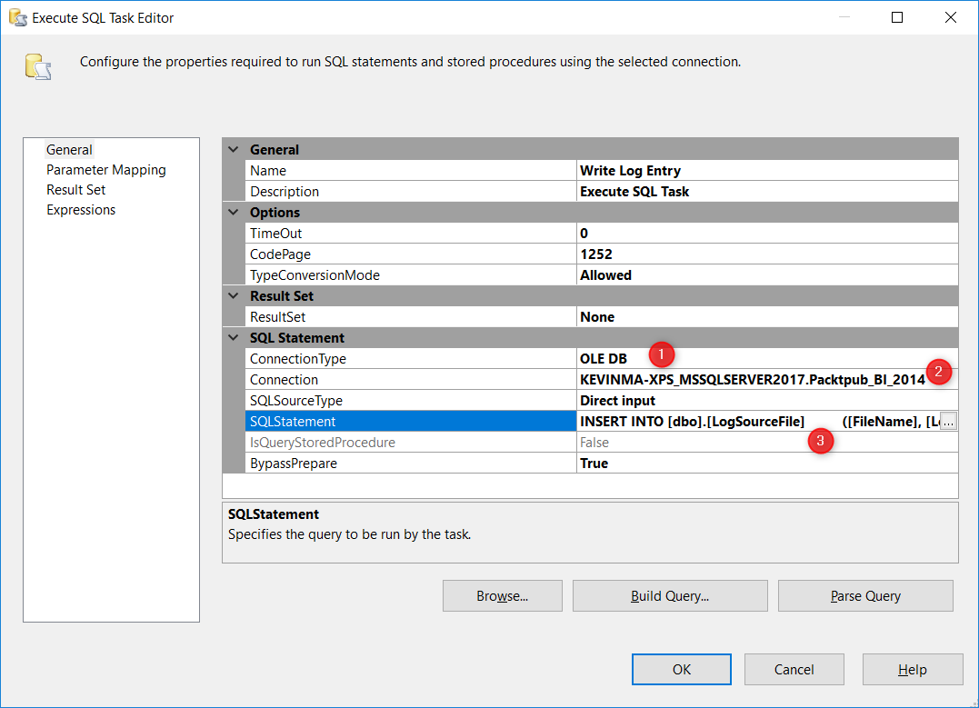

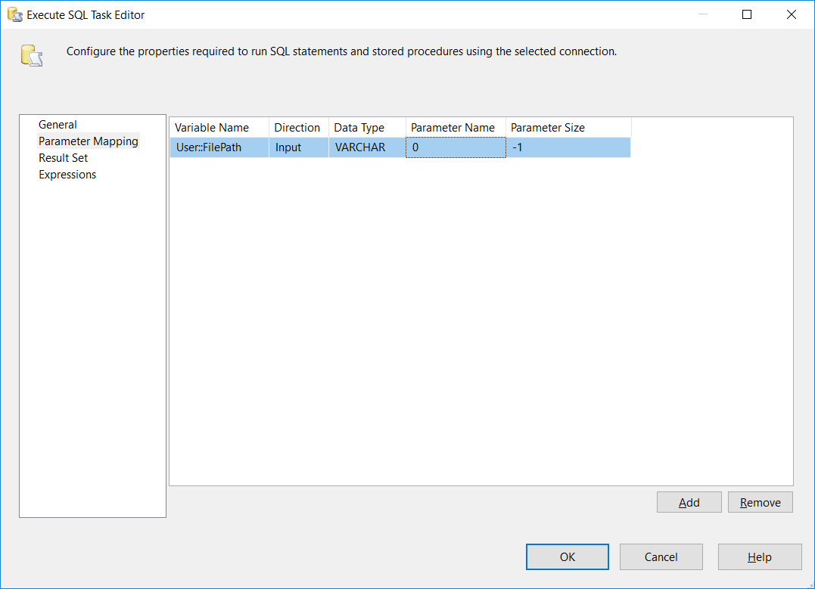

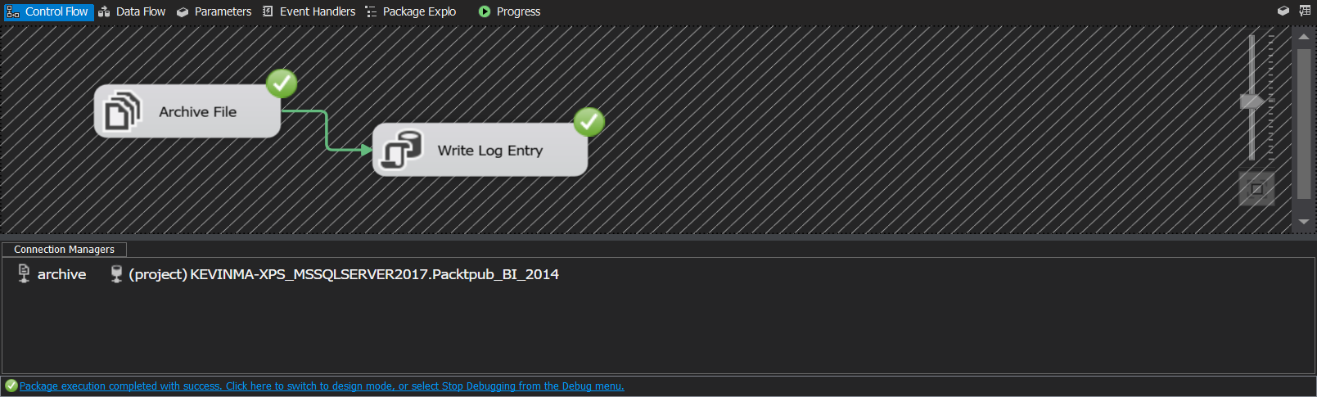

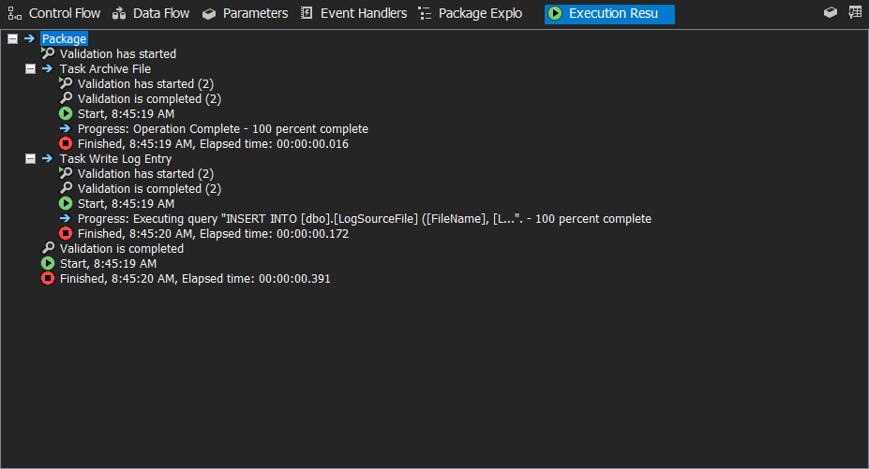

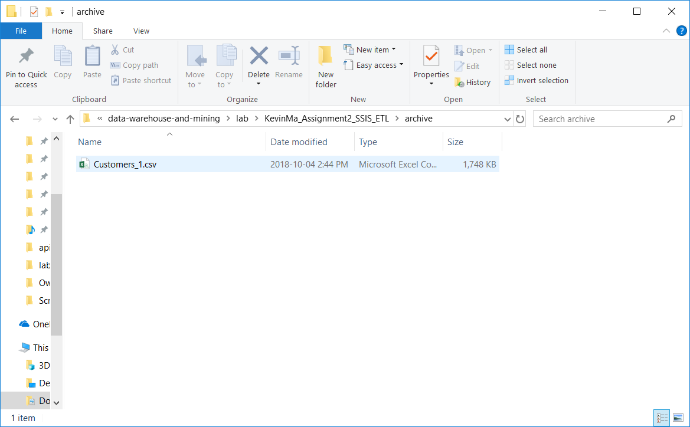

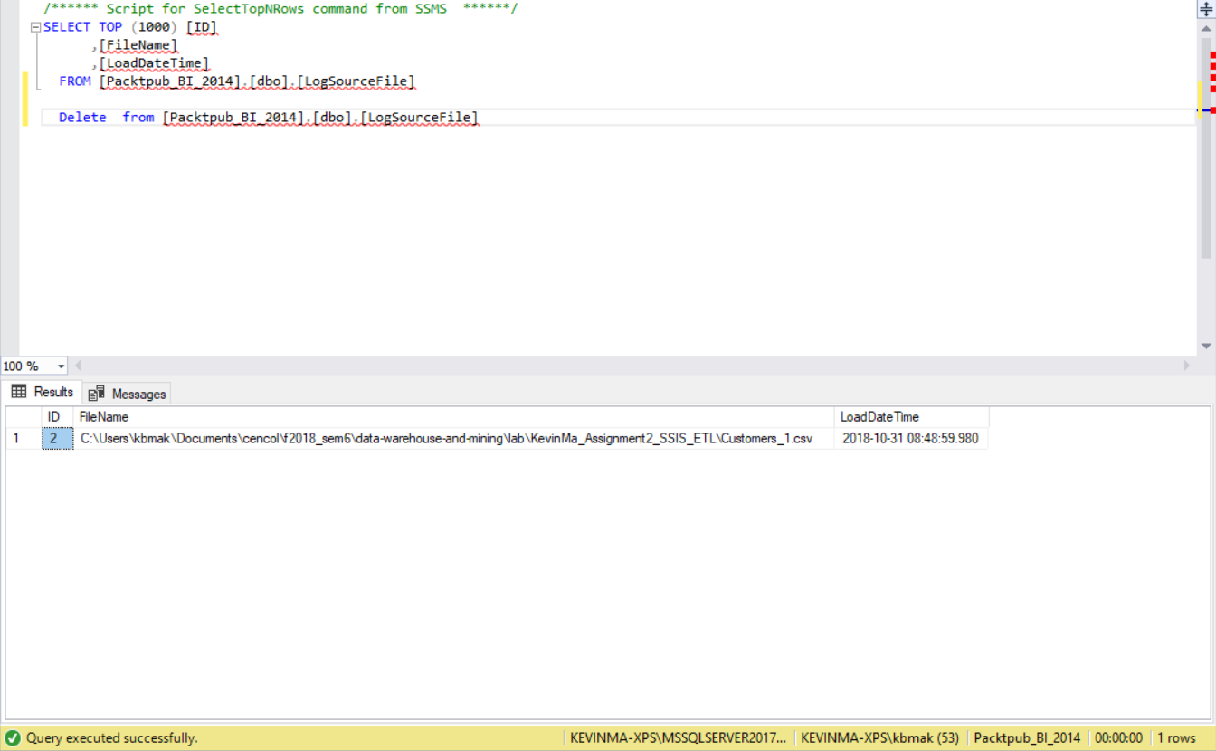

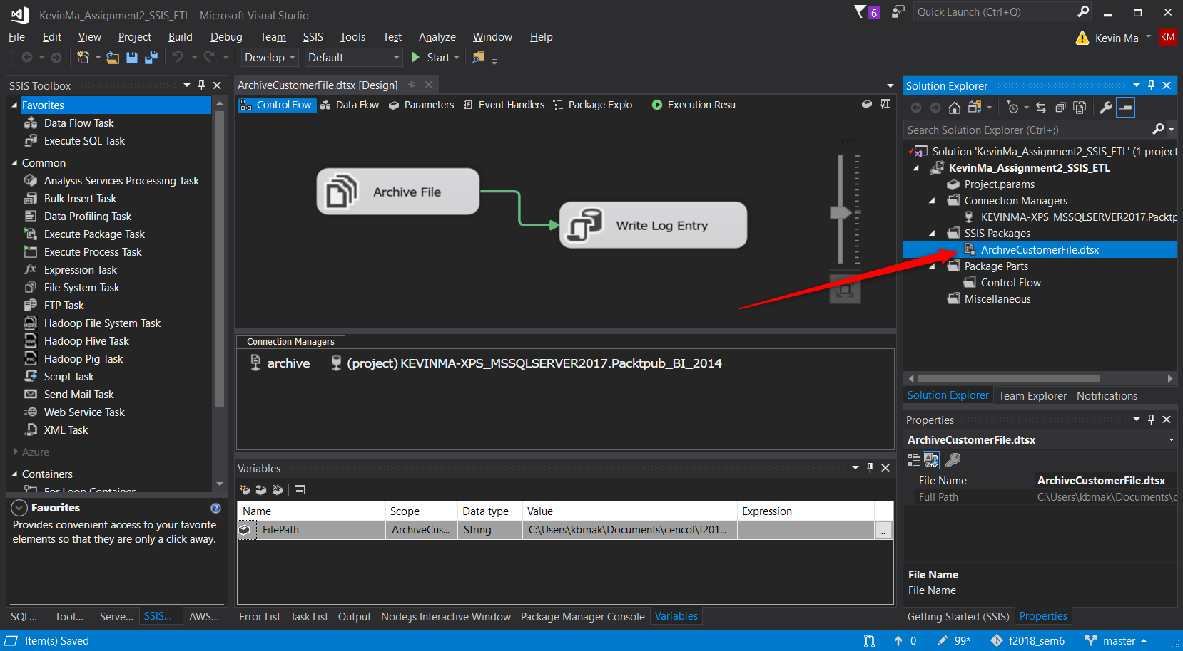

## What did we learn

# Time for action – loading customer information from a flat file into a database table with a Data Flow Task

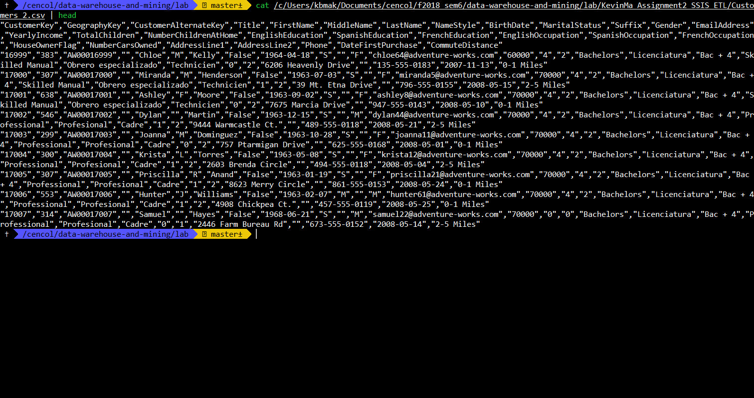

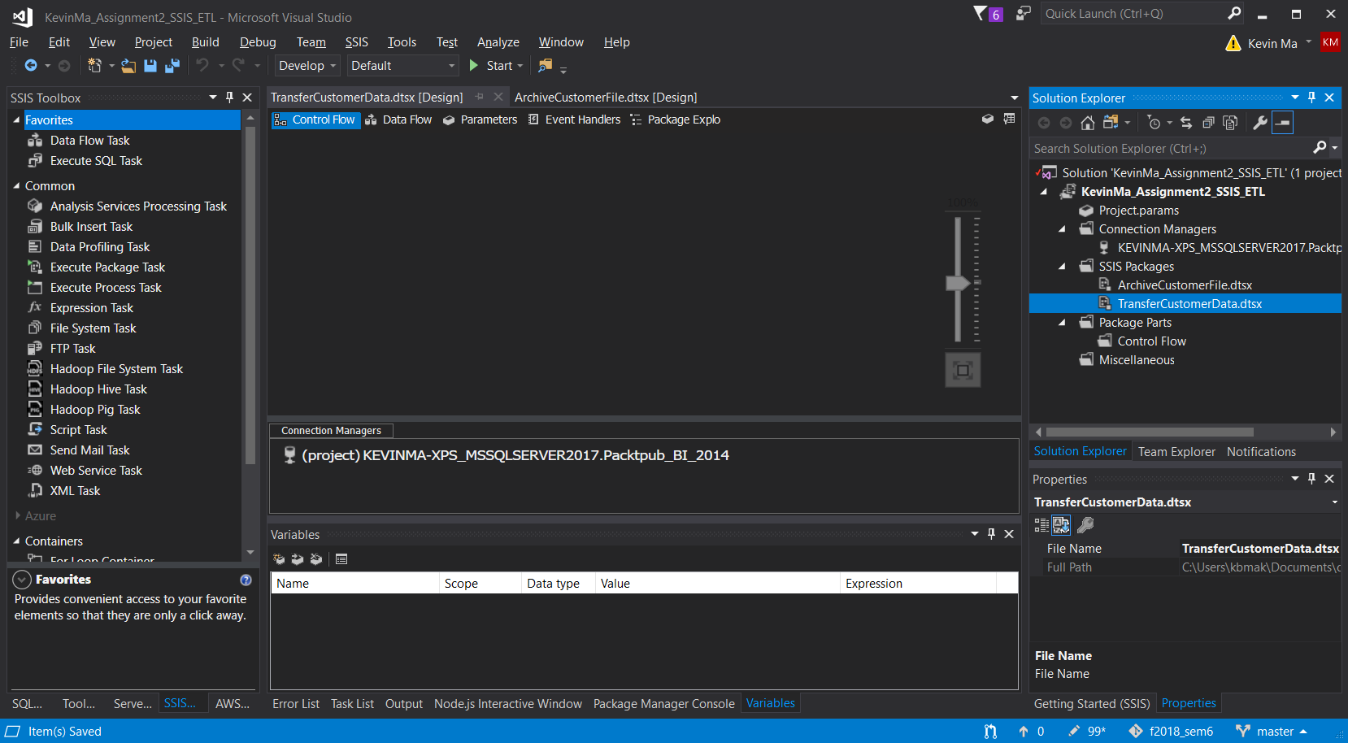

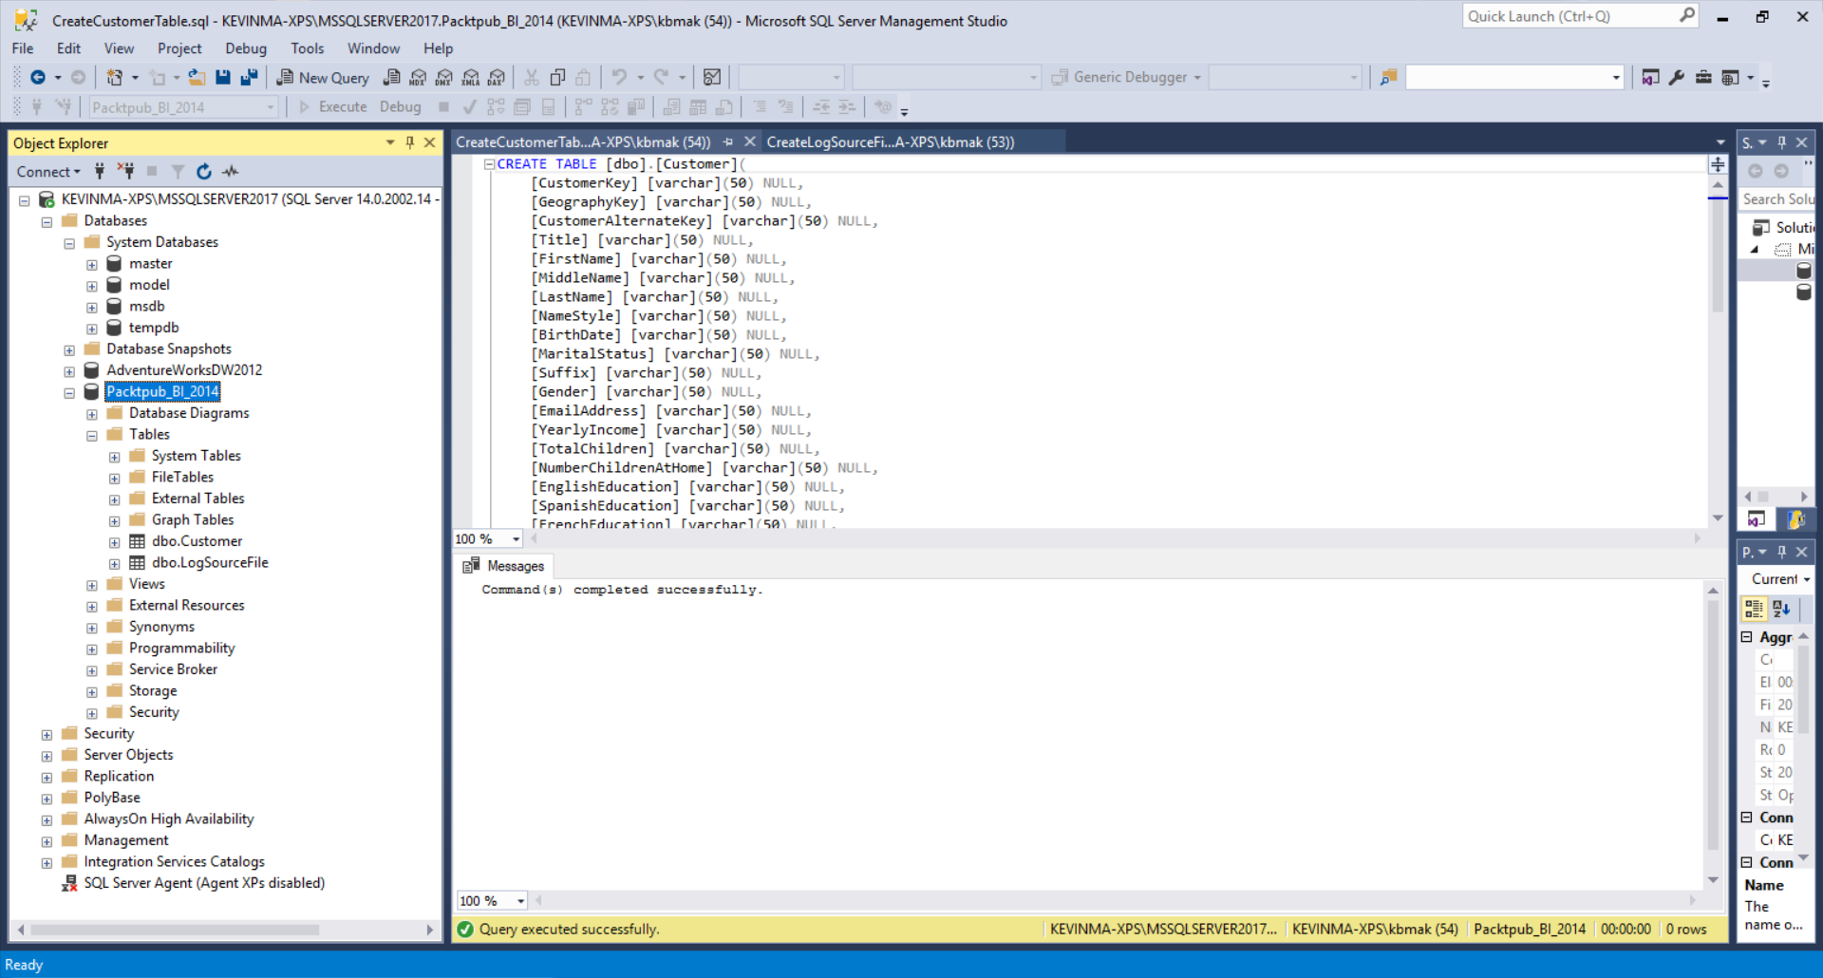

CREATE TABLE [dbo].[Customer](

[CustomerKey] [varchar](50) NULL,

[GeographyKey] [varchar](50) NULL,

[CustomerAlternateKey] [varchar](50) NULL,

[Title] [varchar](50) NULL,

[FirstName] [varchar](50) NULL,

[MiddleName] [varchar](50) NULL,

[LastName] [varchar](50) NULL,

[NameStyle] [varchar](50) NULL,

[BirthDate] [varchar](50) NULL,

[MaritalStatus] [varchar](50) NULL,

[Suffix] [varchar](50) NULL,

[Gender] [varchar](50) NULL,

[EmailAddress] [varchar](50) NULL,

[YearlyIncome] [varchar](50) NULL,

[TotalChildren] [varchar](50) NULL,

[NumberChildrenAtHome] [varchar](50) NULL,

[EnglishEducation] [varchar](50) NULL,

[SpanishEducation] [varchar](50) NULL,

[FrenchEducation] [varchar](50) NULL,

[EnglishOccupation] [varchar](50) NULL,

[SpanishOccupation] [varchar](50) NULL,

[FrenchOccupation] [varchar](50) NULL,

[HouseOwnerFlag] [varchar](50) NULL,

[NumberCarsOwned] [varchar](50) NULL,

[AddressLine1] [varchar](50) NULL,

[AddressLine2] [varchar](50) NULL,

[Phone] [varchar](50) NULL,

[DateFirstPurchase] [varchar](50) NULL,

[CommuteDistance] [varchar](50) NULL,

[Age] [int] NULL

) ON [PRIMARY]

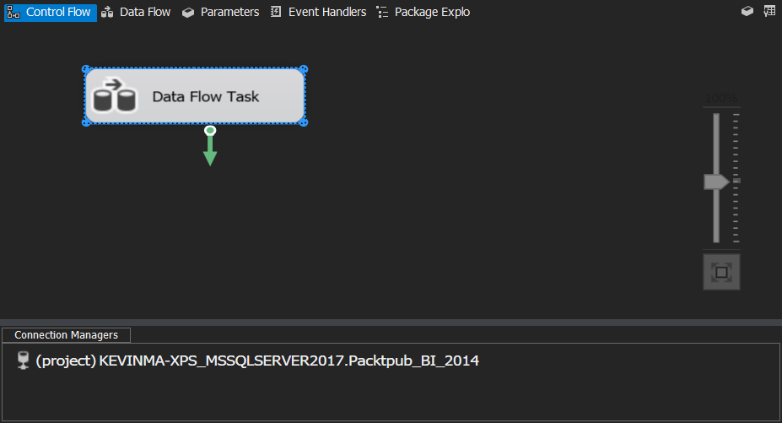

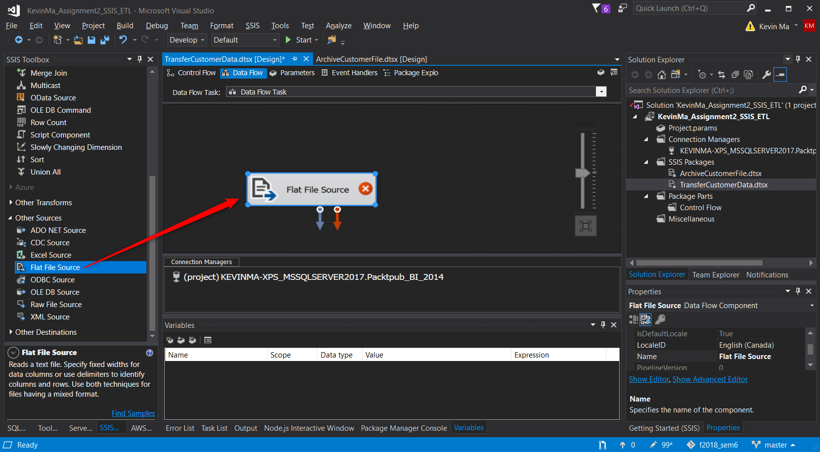

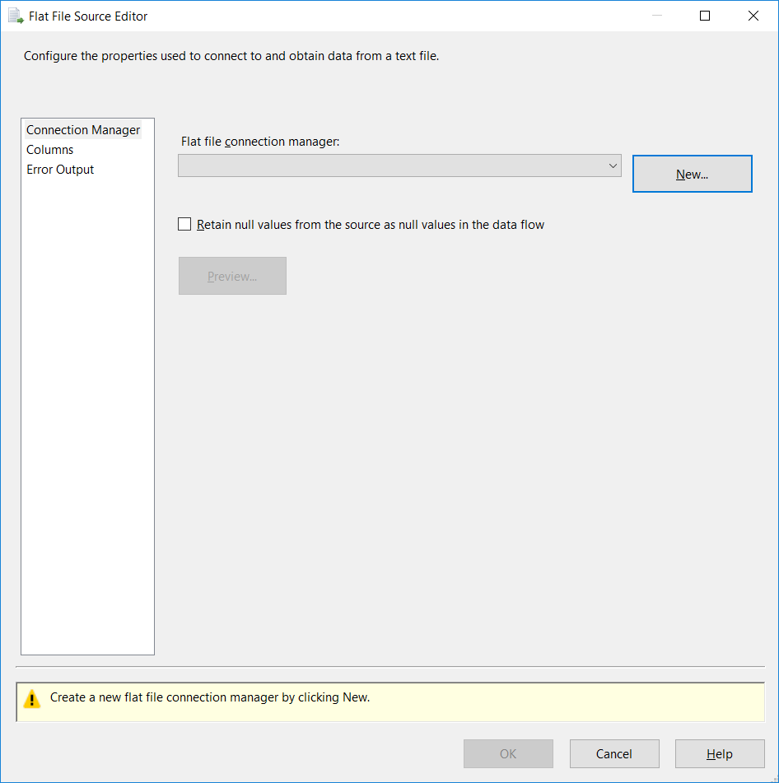

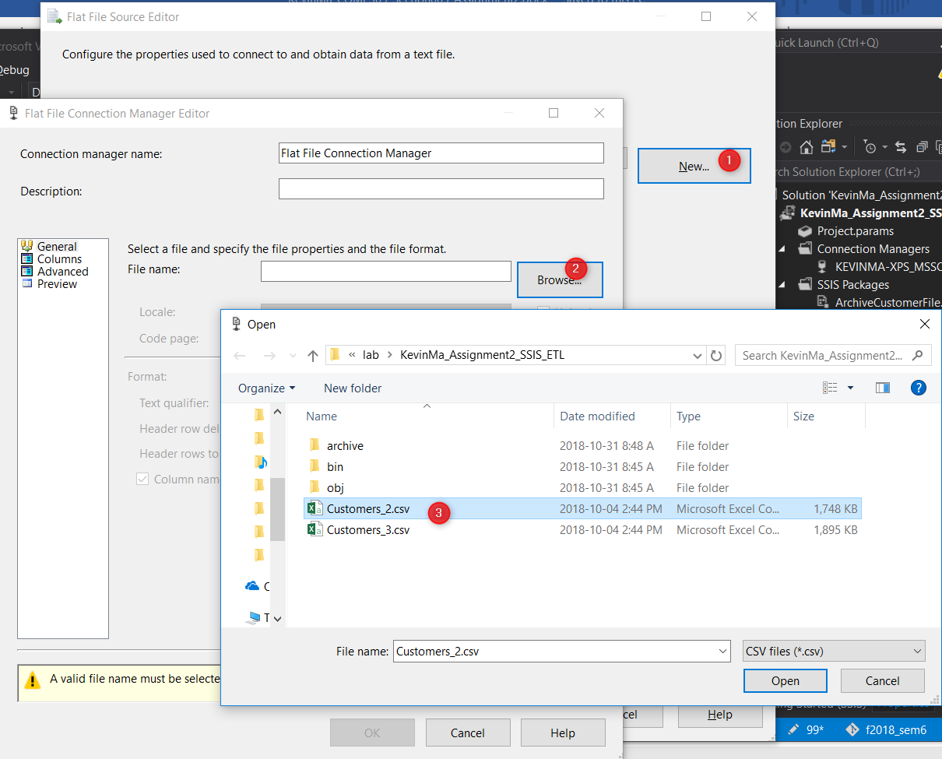

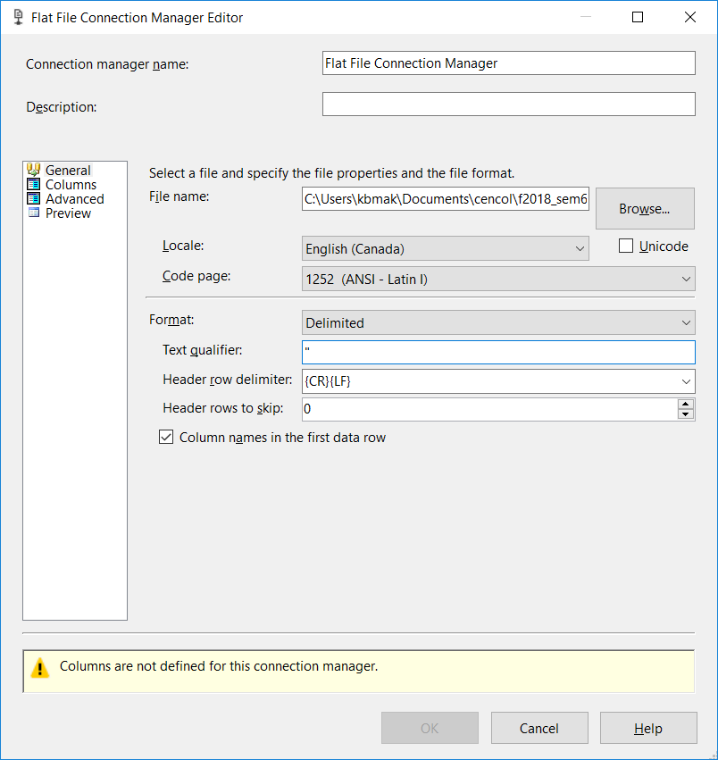

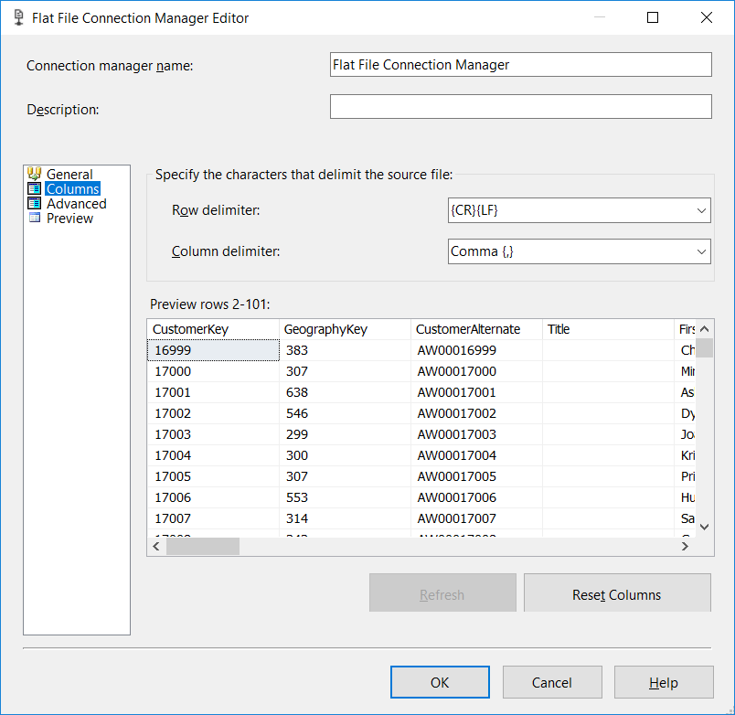

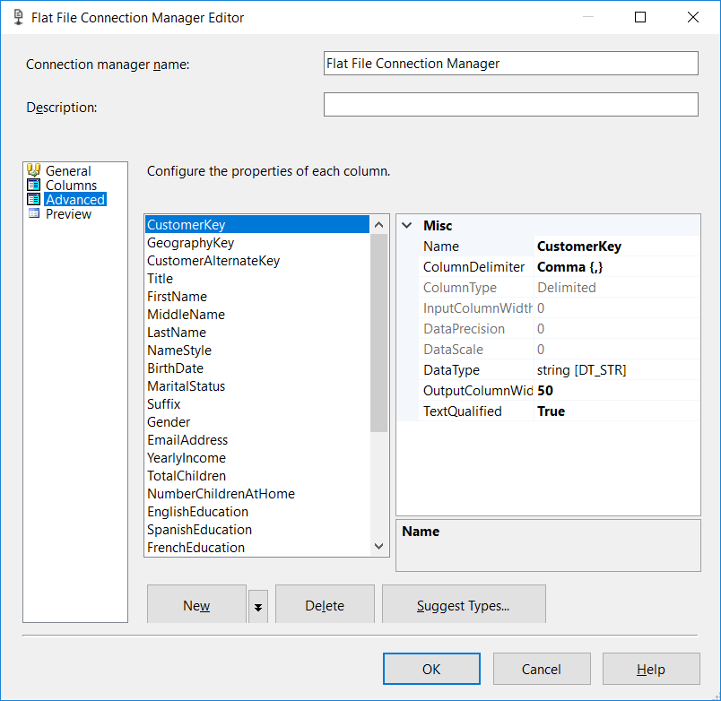

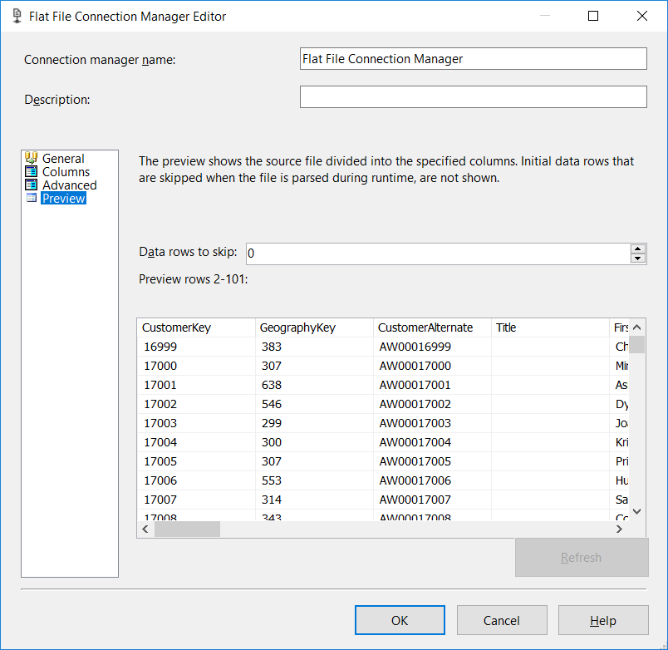

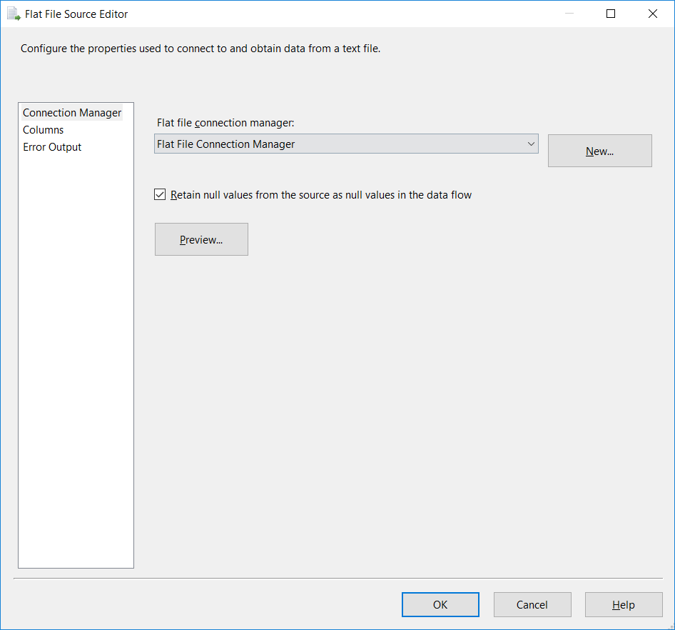

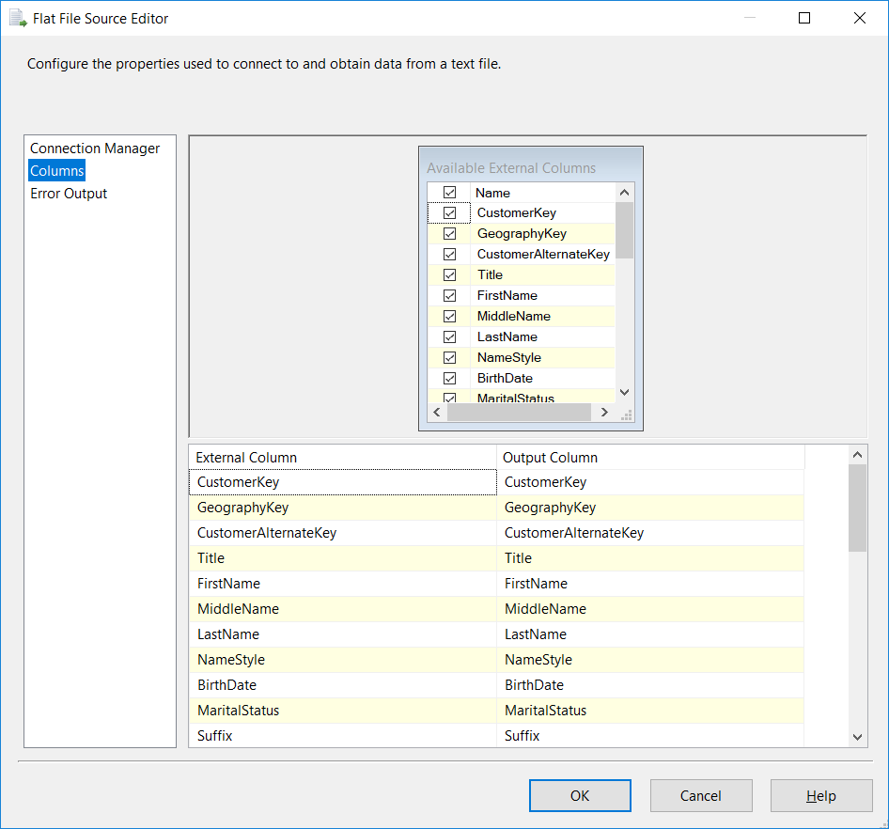

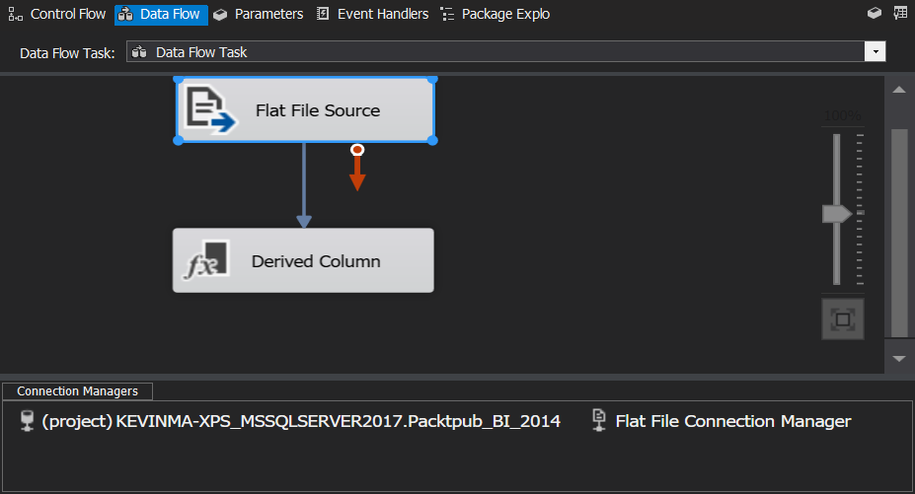

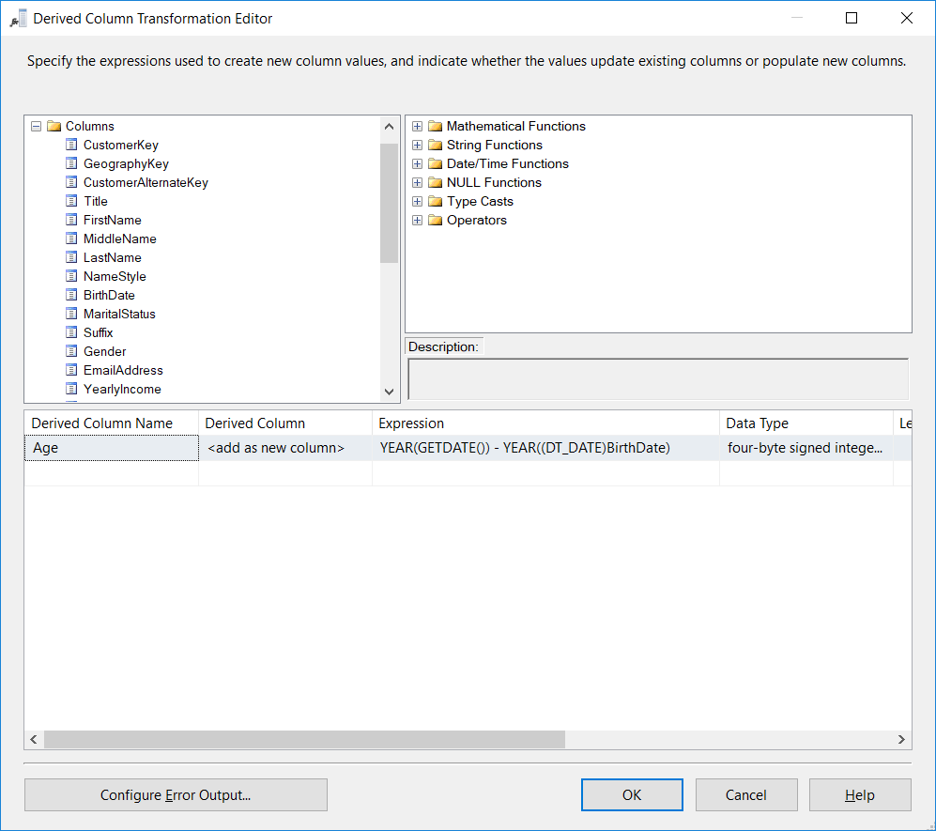

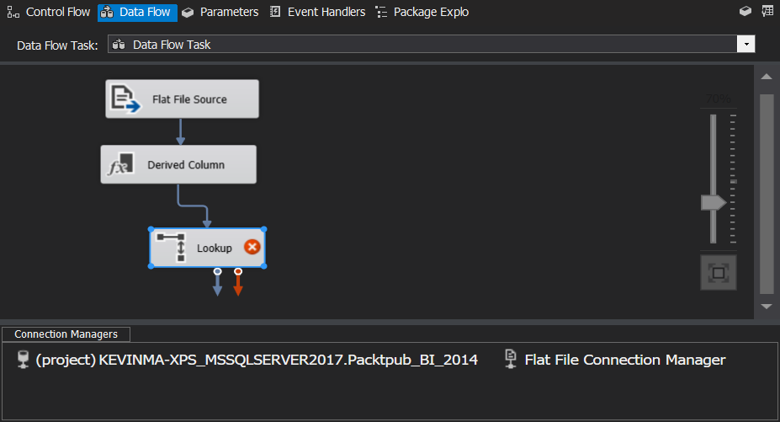

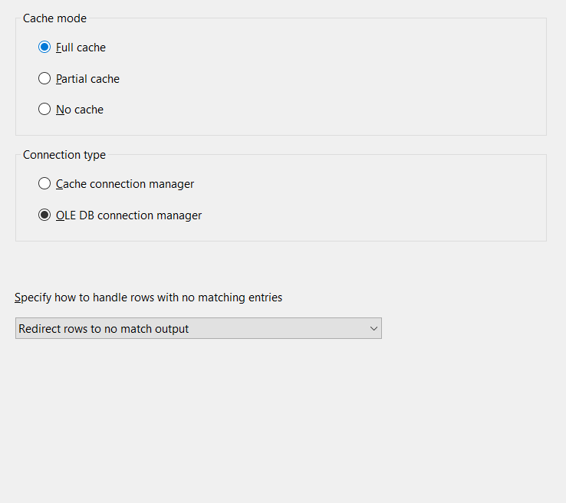

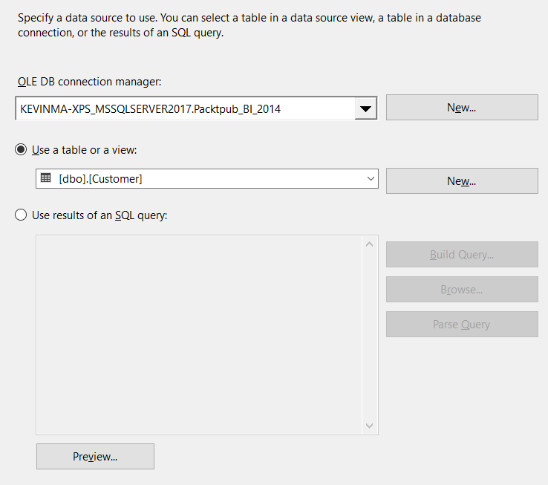

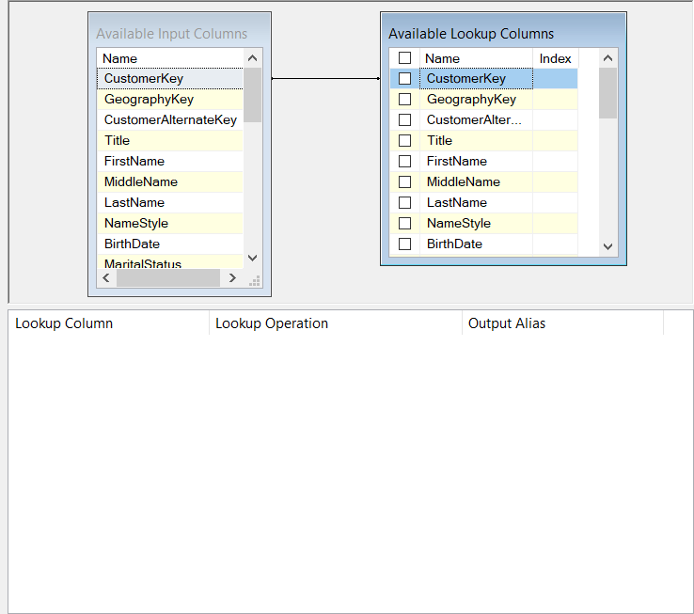

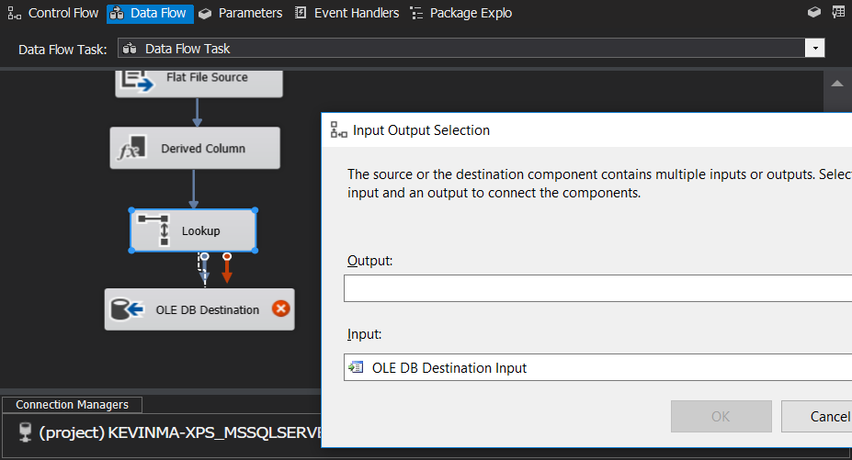

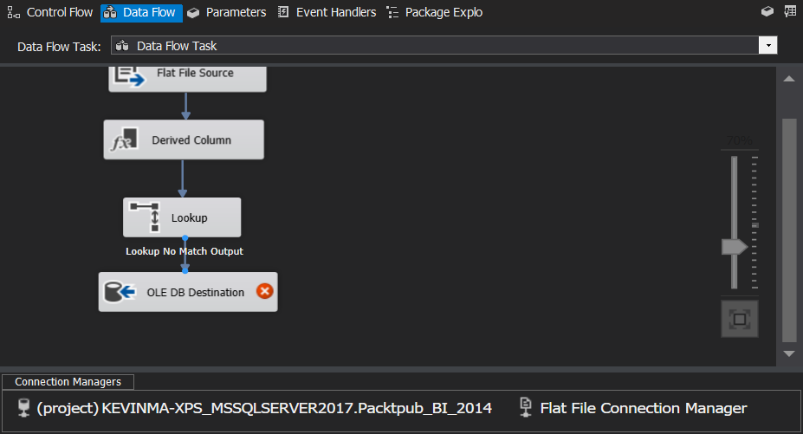

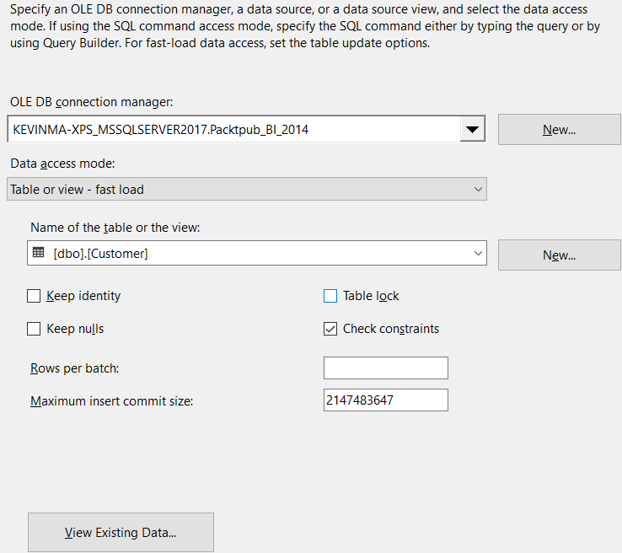

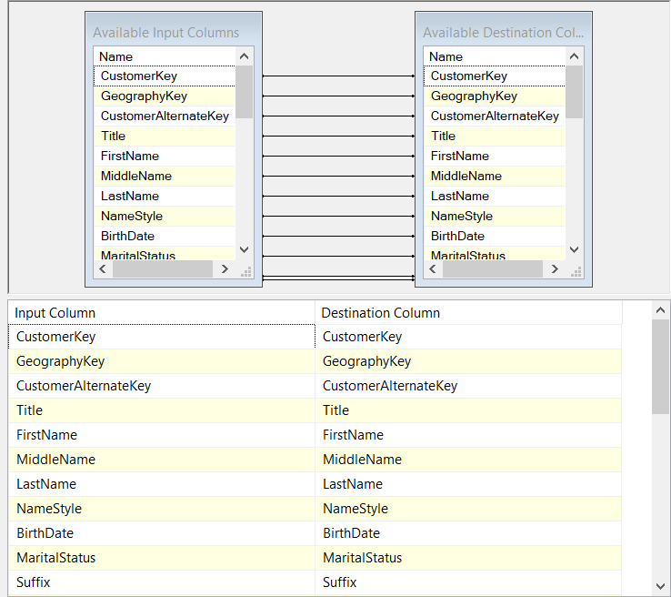

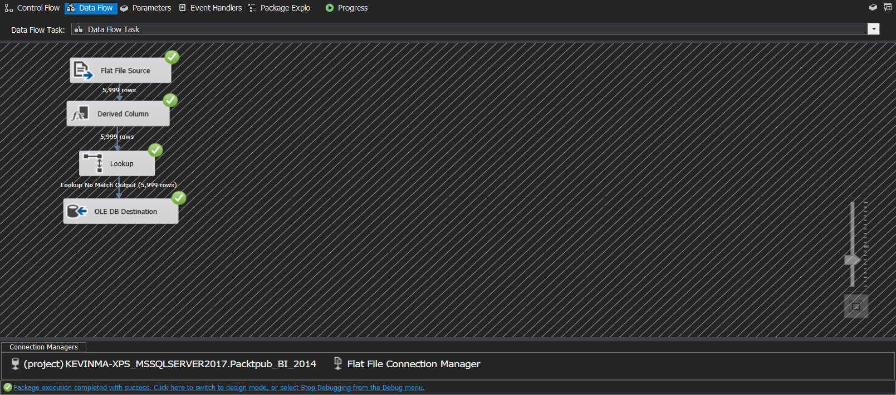

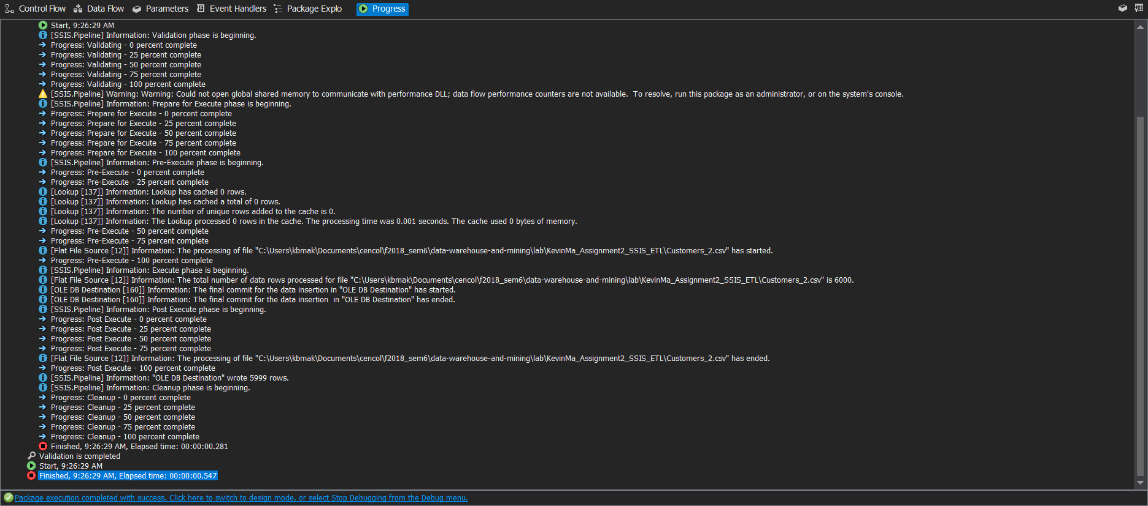

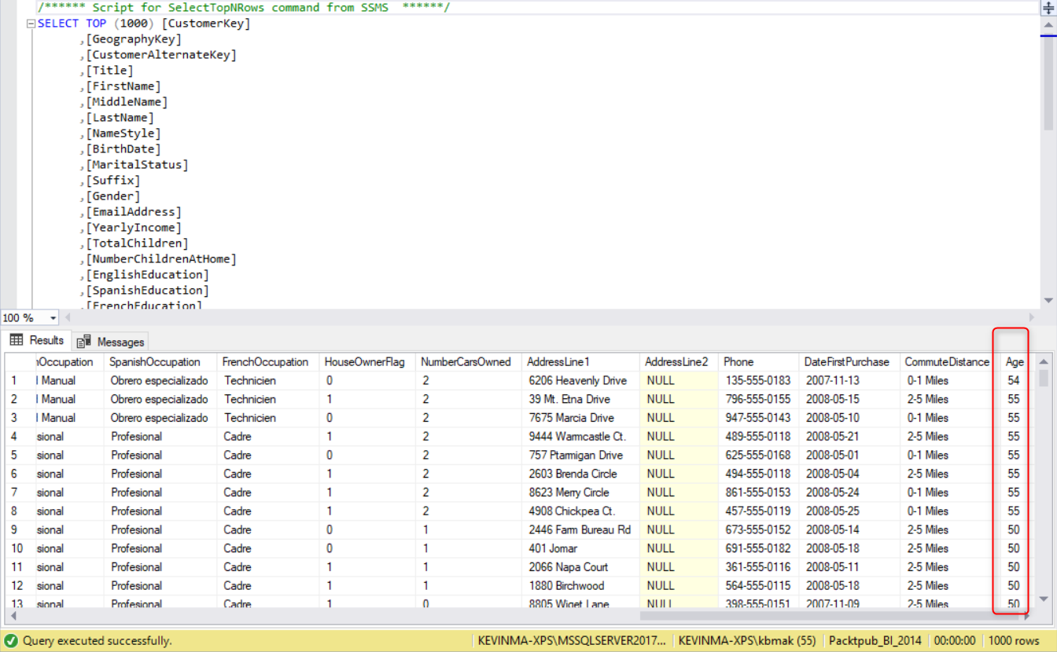

## What did we learn

# Time for action – looping through CSV files in a directory and loading them into a database table

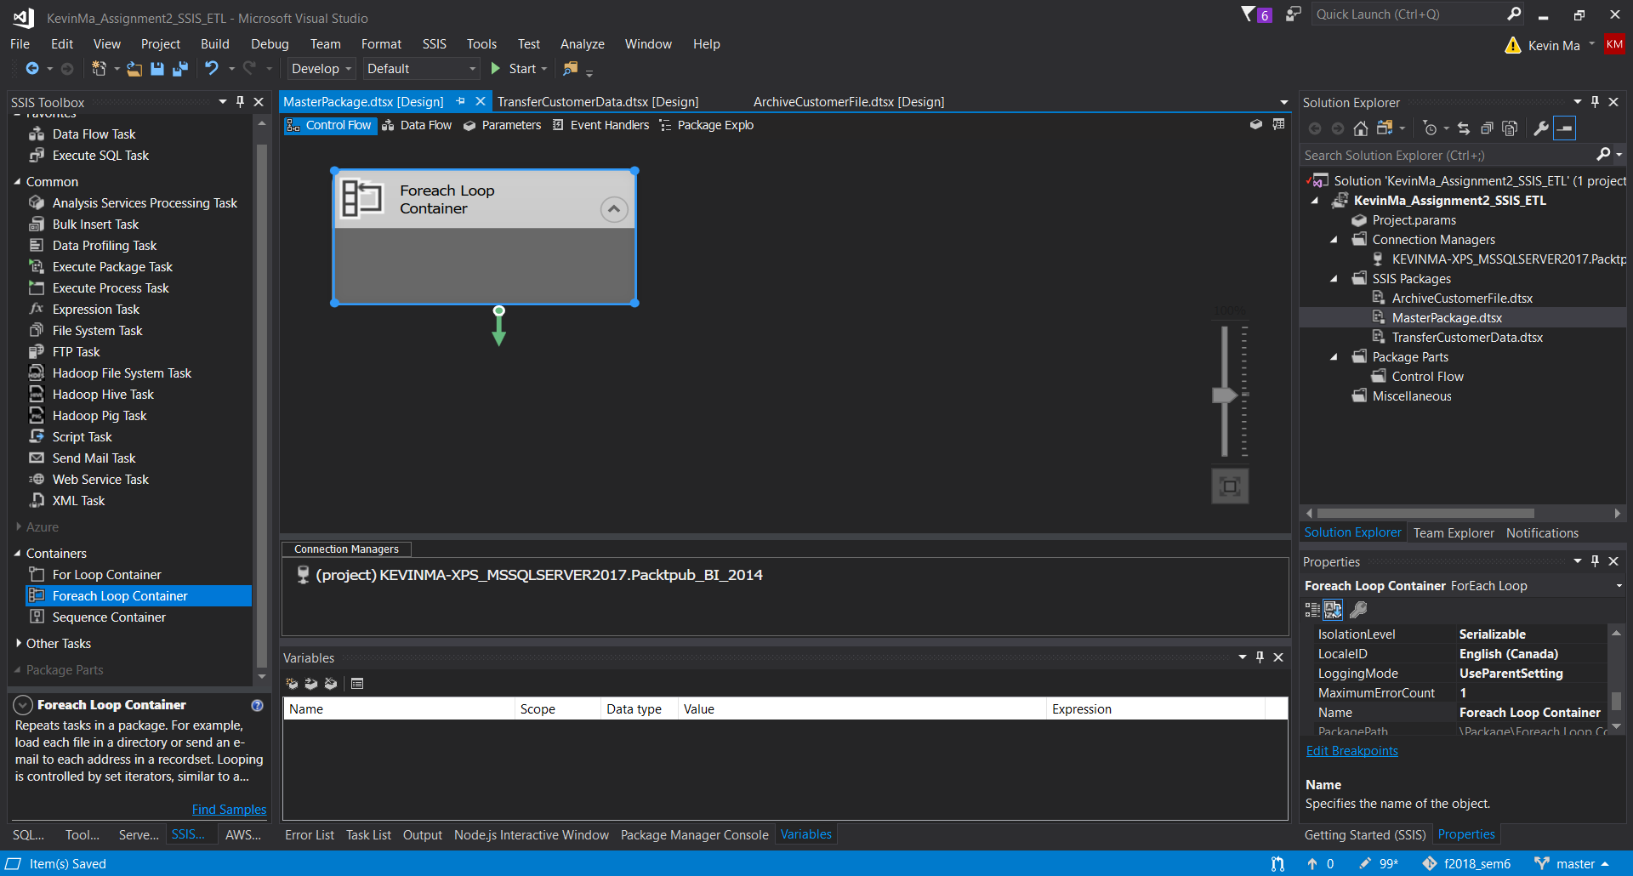

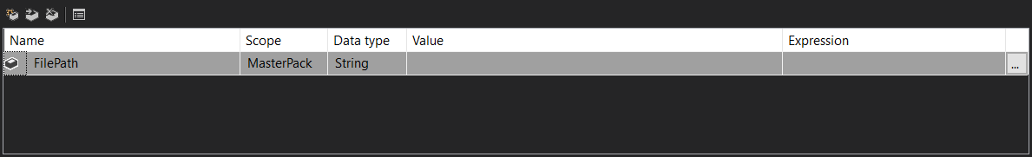

Instructions forgot to mention the enumerator was under collections tab

Also instructions forgot to mention to change files to monitor only *.csv files

This caused much anguish and wasted time trying to trouble shoot the errors which arose when running the master package:

[Flat File Source [12]] Error: An error occurred while skipping data rows.

[SSIS.Pipeline] Error: SSIS Error Code DTS_E_PRIMEOUTPUTFAILED. The PrimeOutput method on Flat File Source returned error code 0xC0202091. The component returned a failure code when the pipeline engine called PrimeOutput(). The meaning of the failure code is defined by the component, but the error is fatal and the pipeline stopped executing. There may be error messages posted before this with more information about the failure.

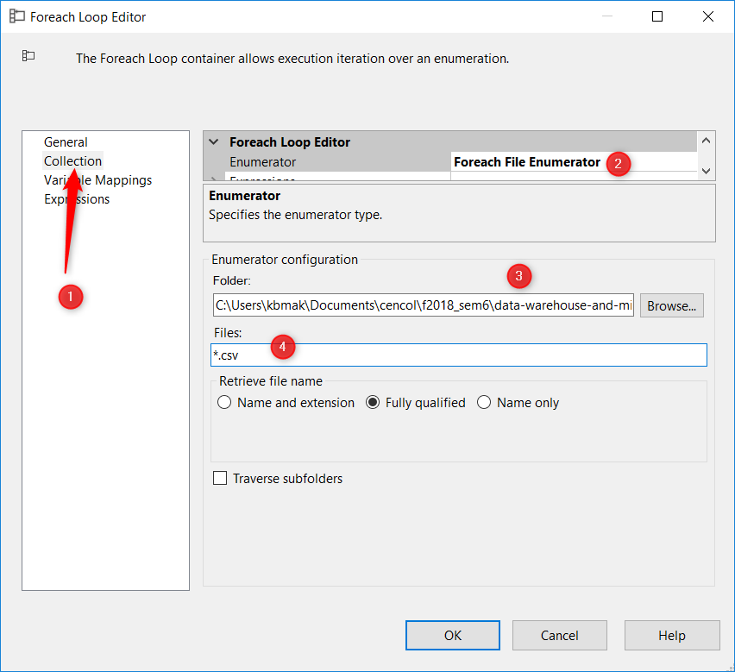

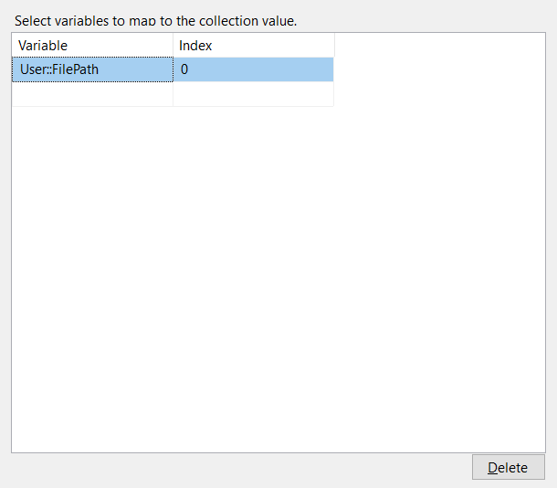

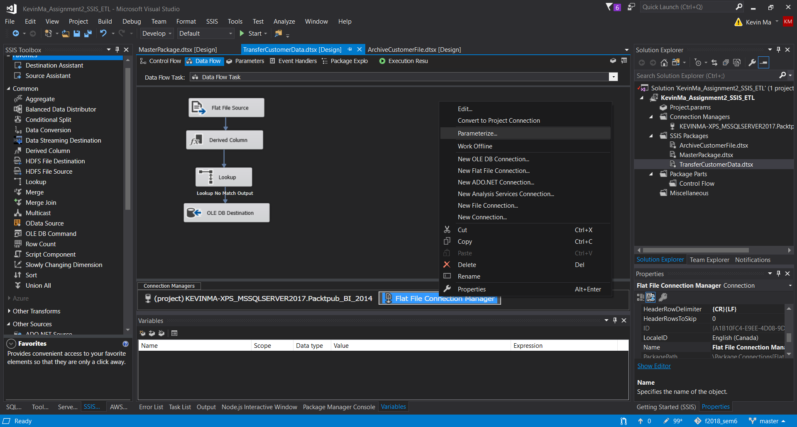

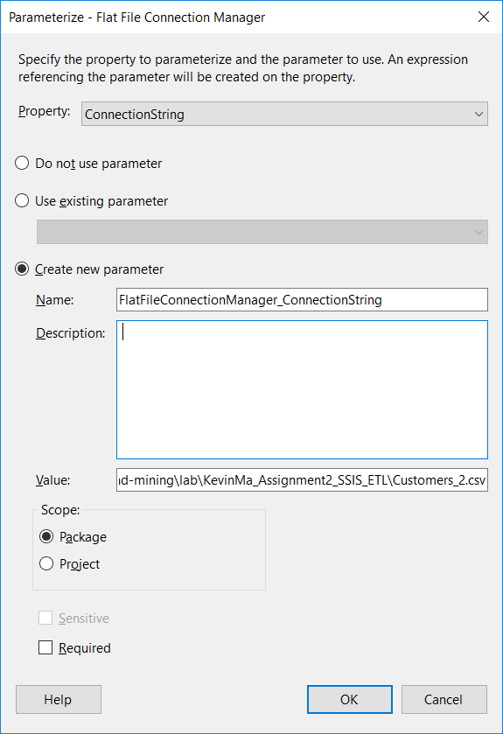

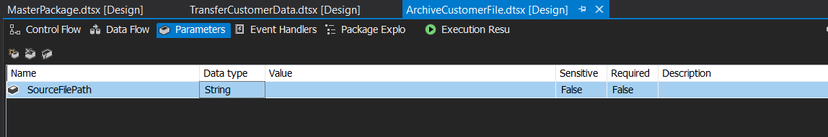

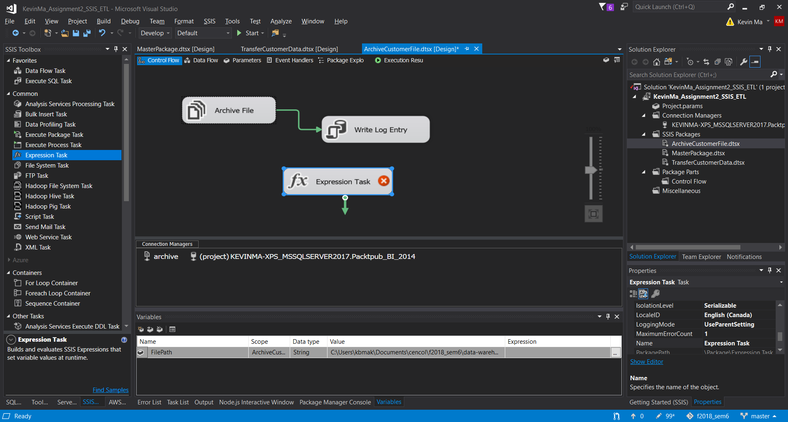

@[User::FilePath]= @[$Package::SourceFilePath]

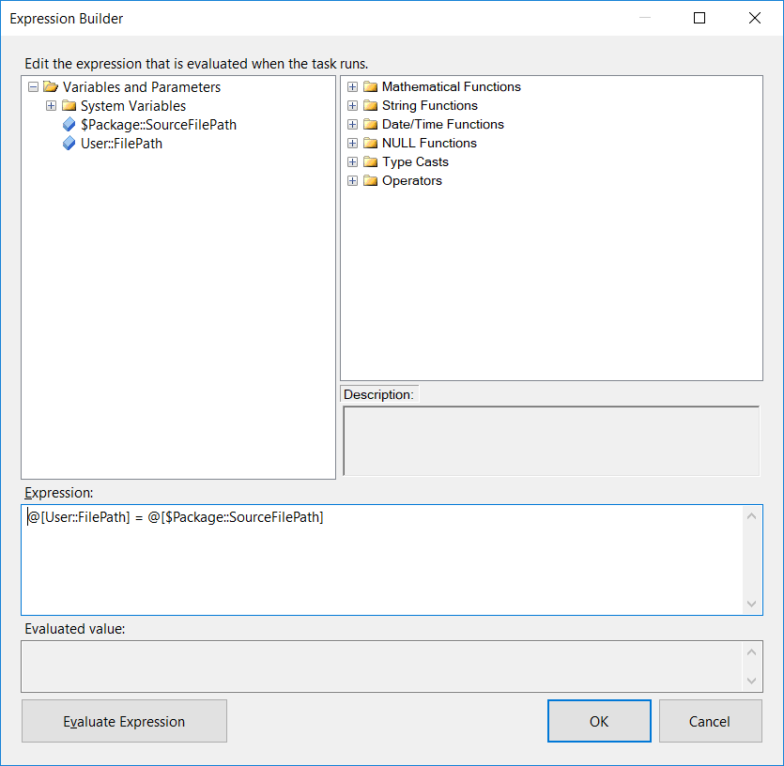

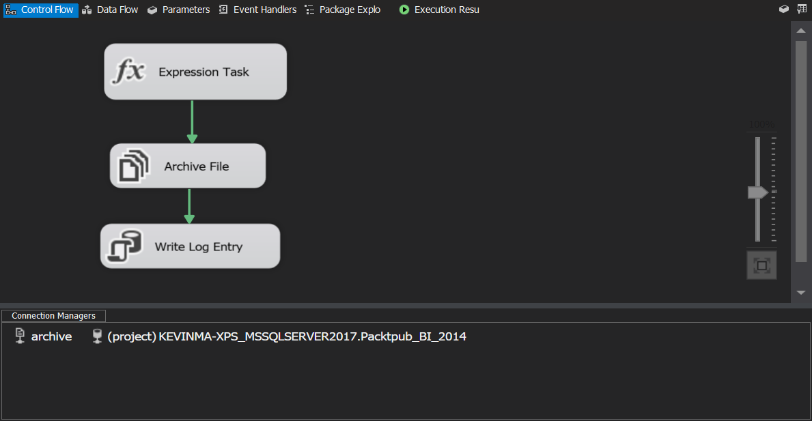

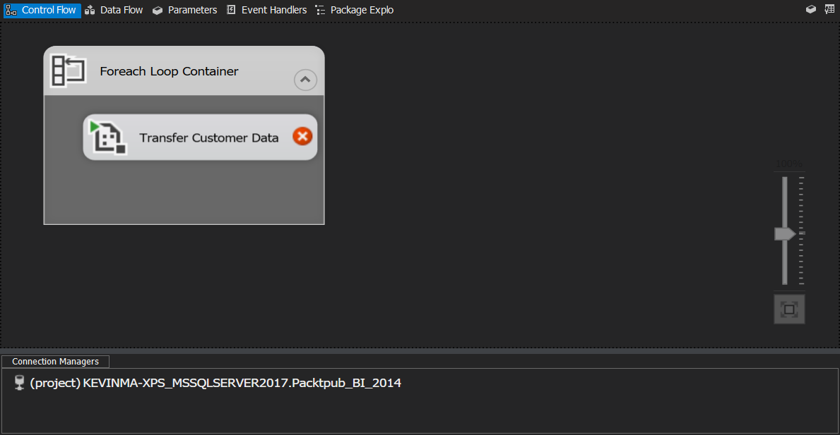

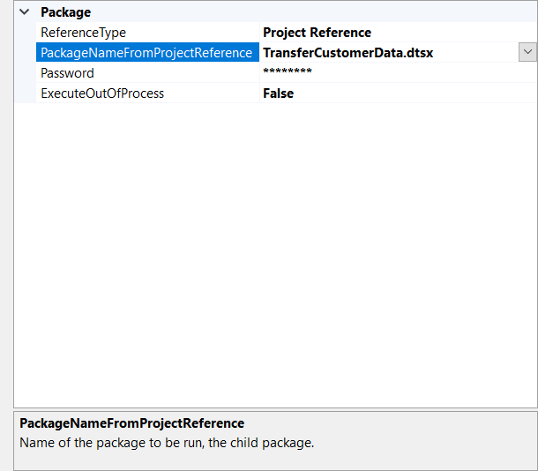

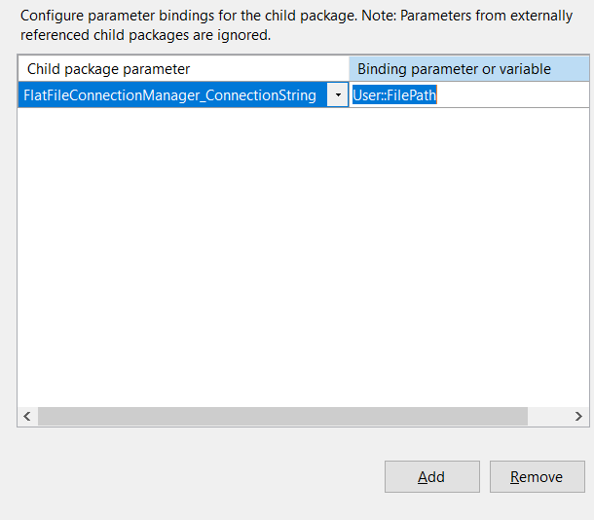

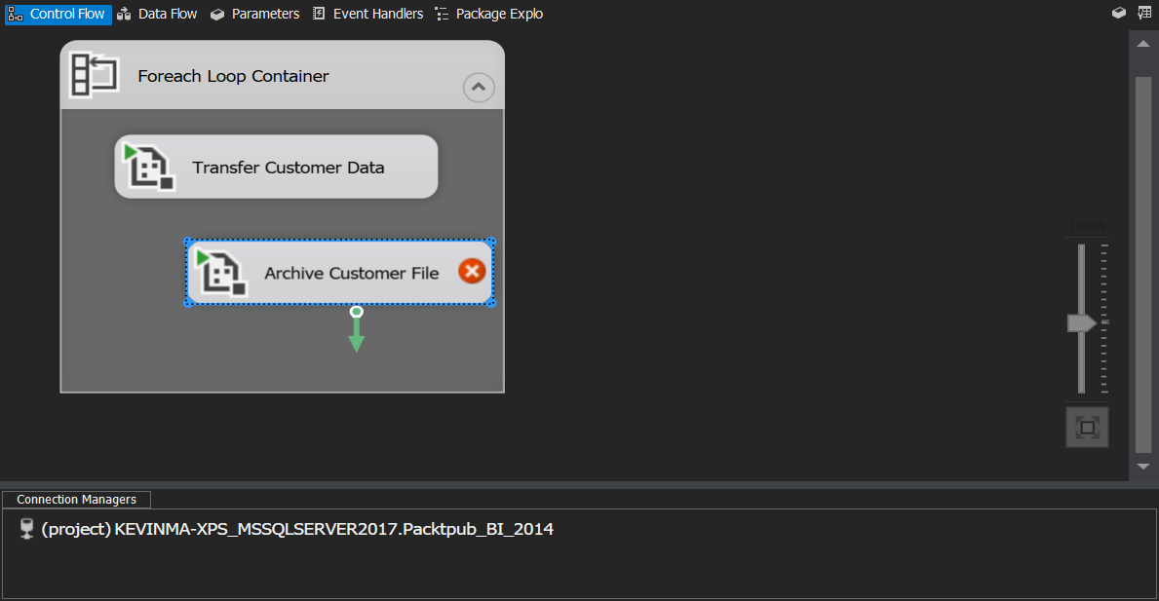

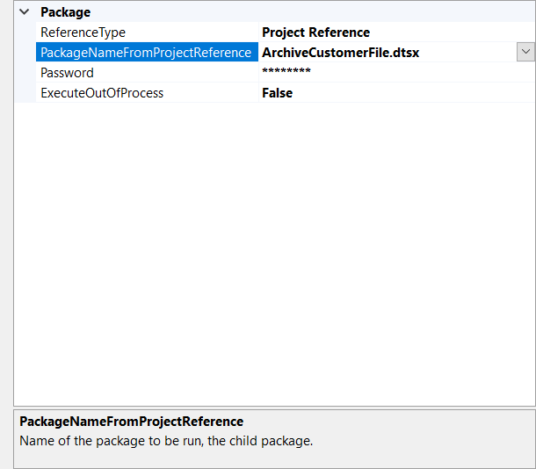

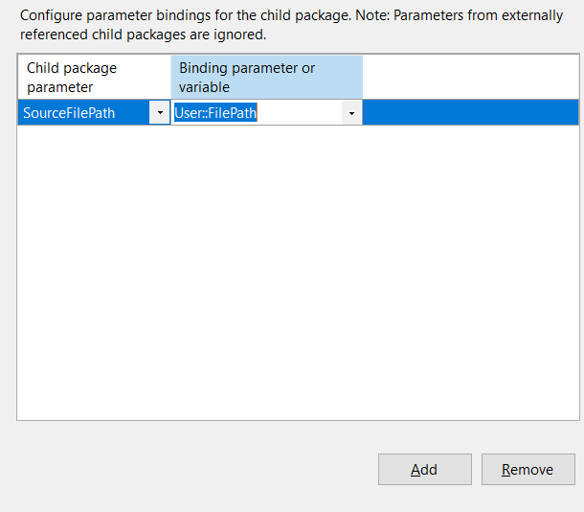

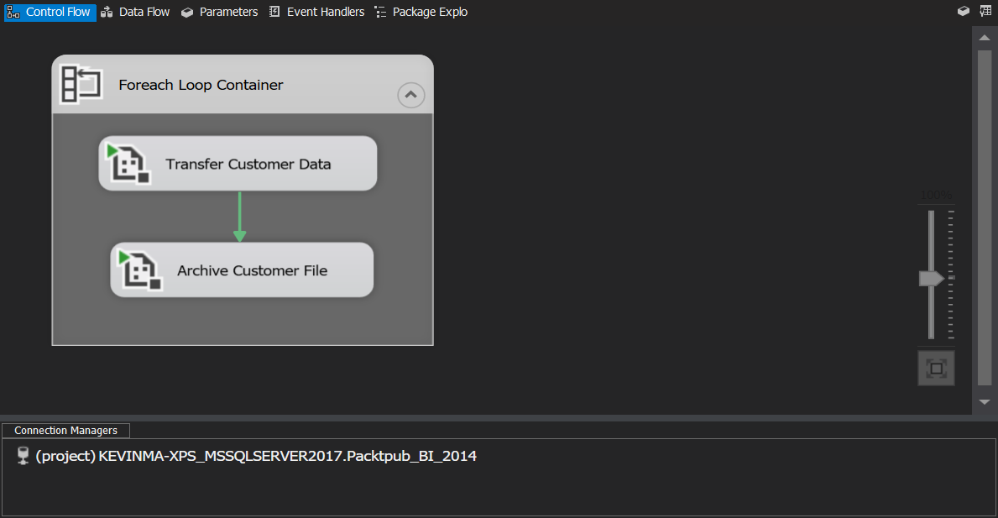

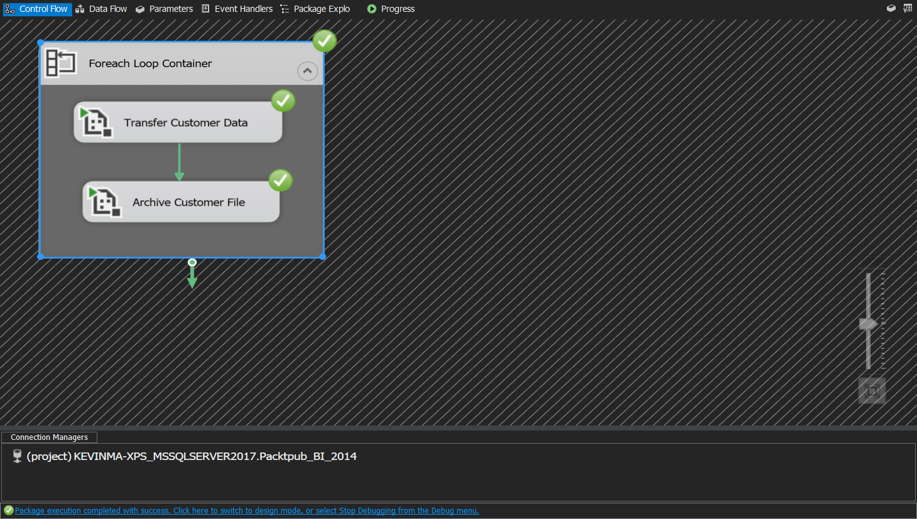

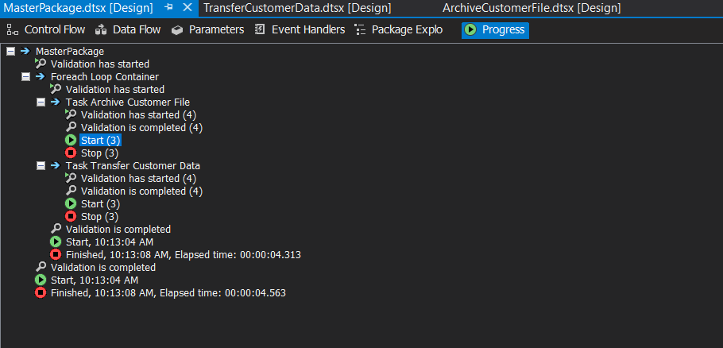

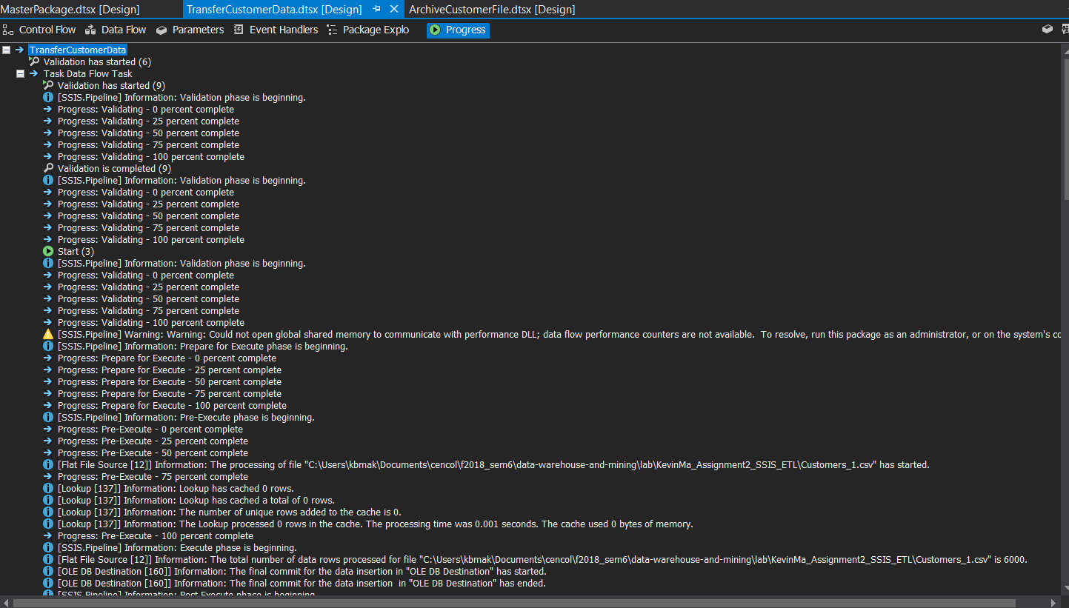

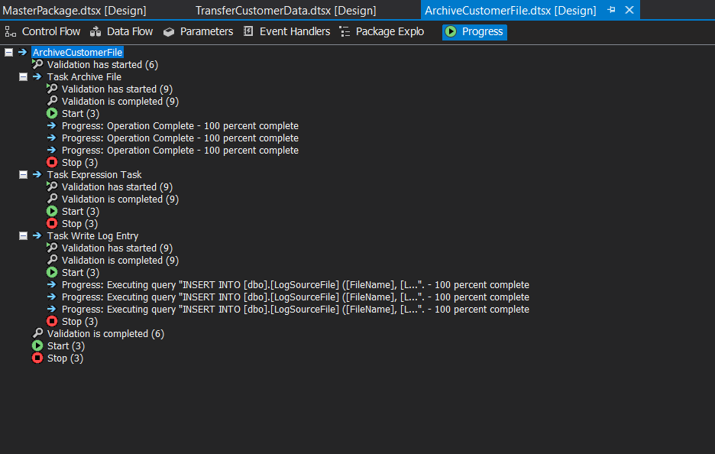

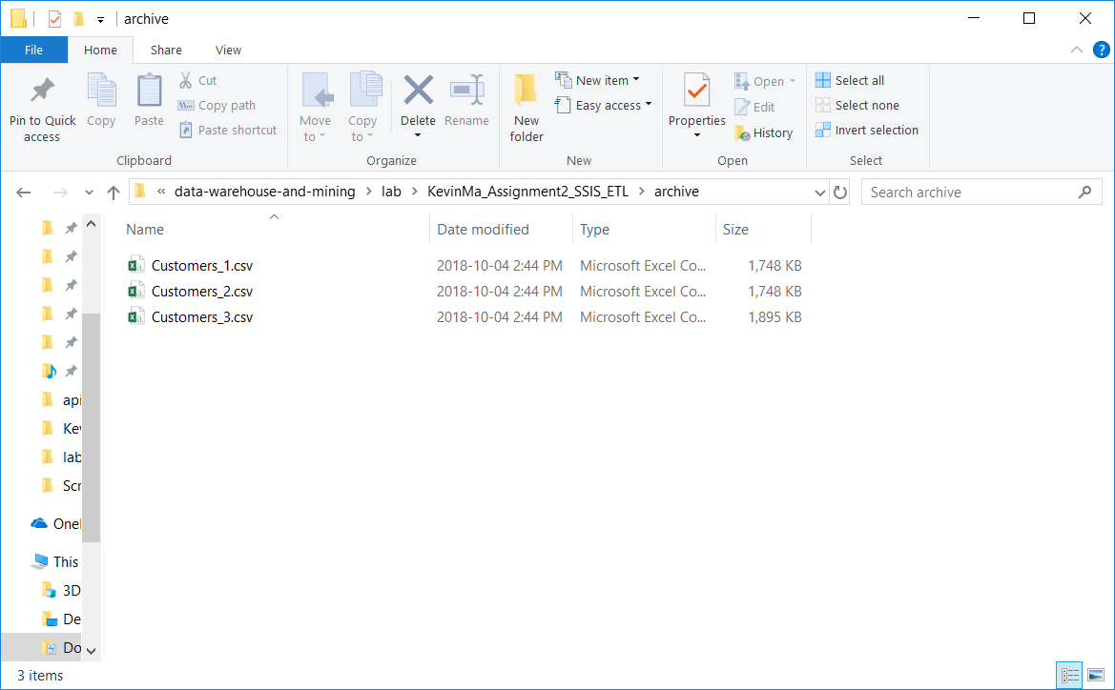

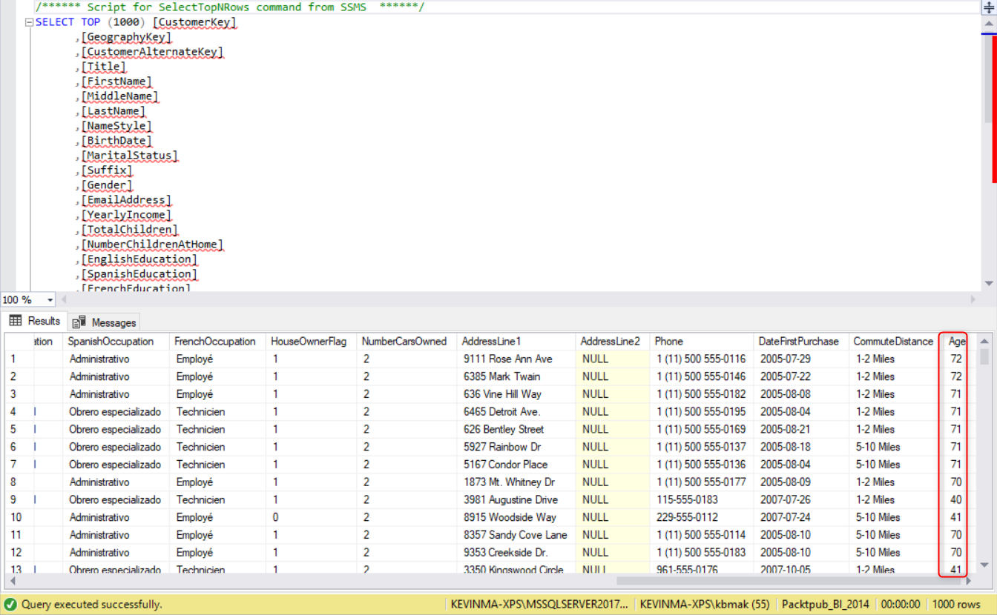

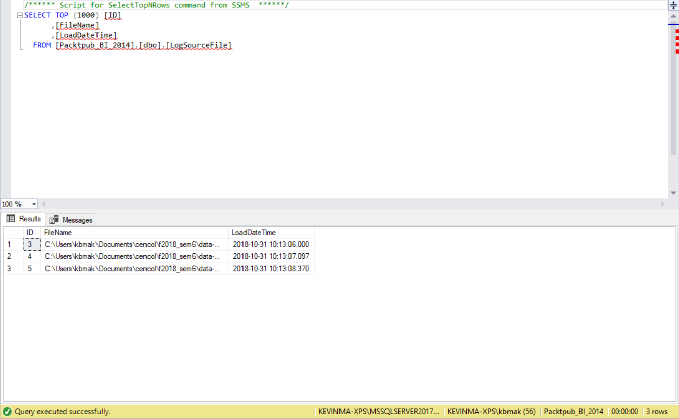

## What did we learn

# Time for action – deploying an SSIS project

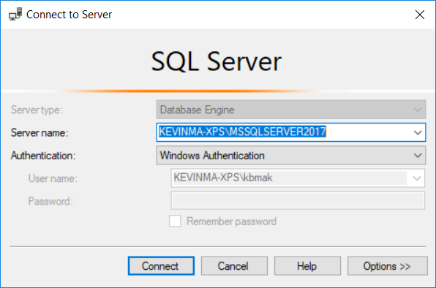

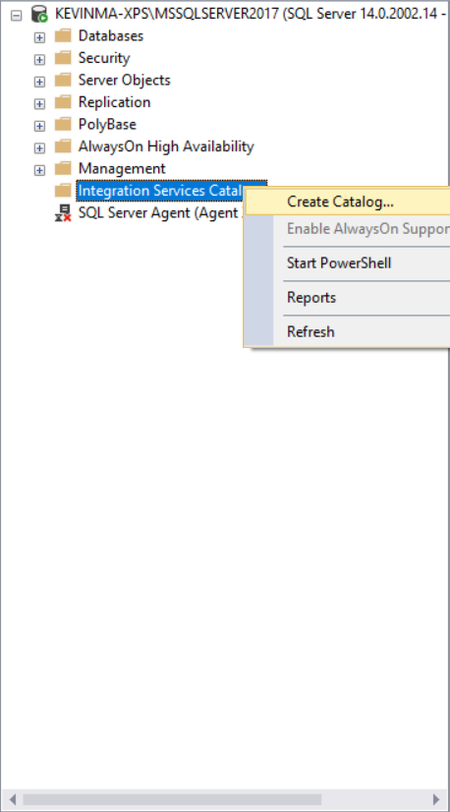

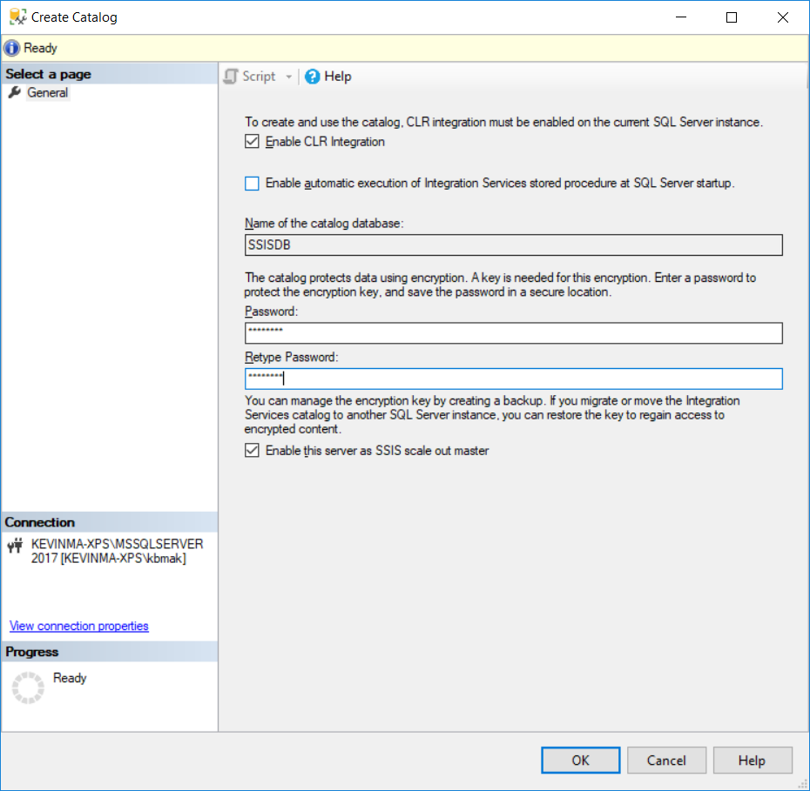

***cannot do this

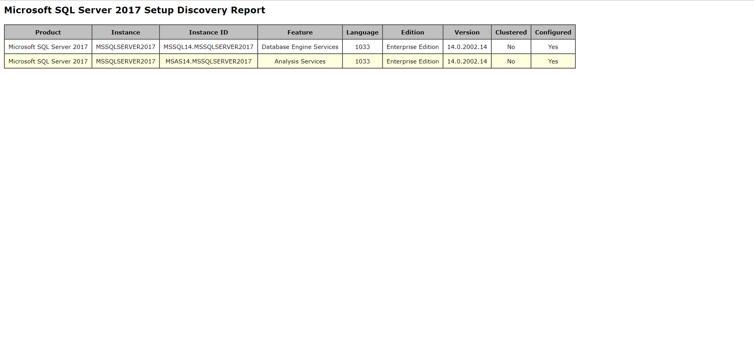

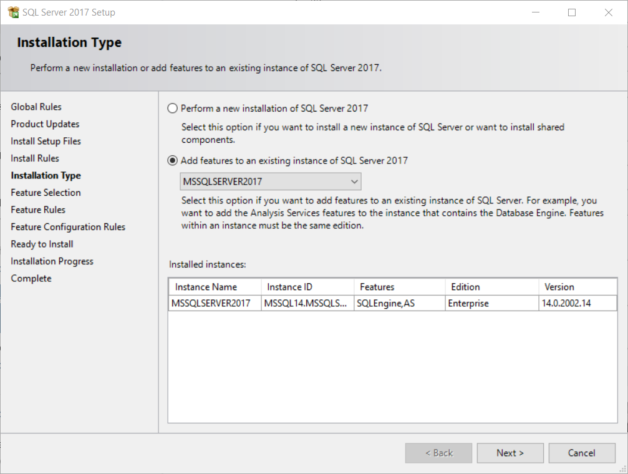

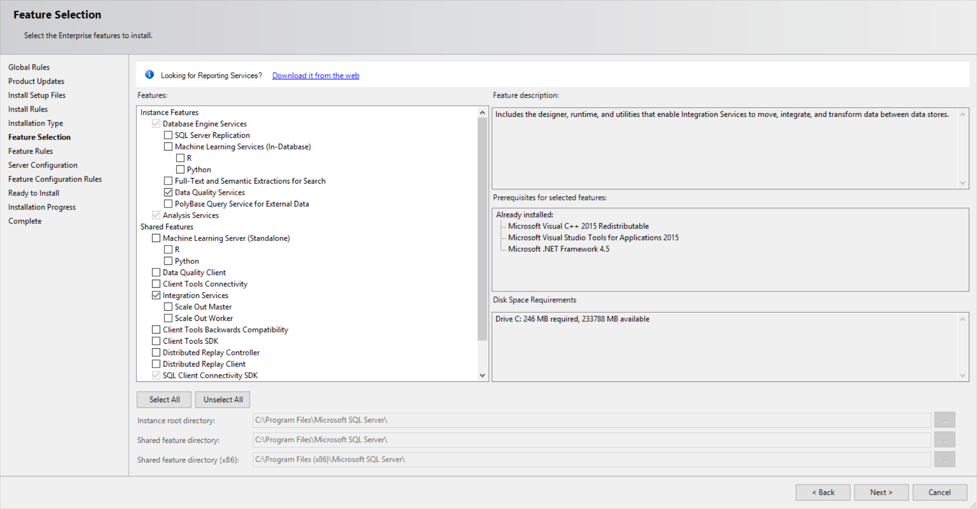

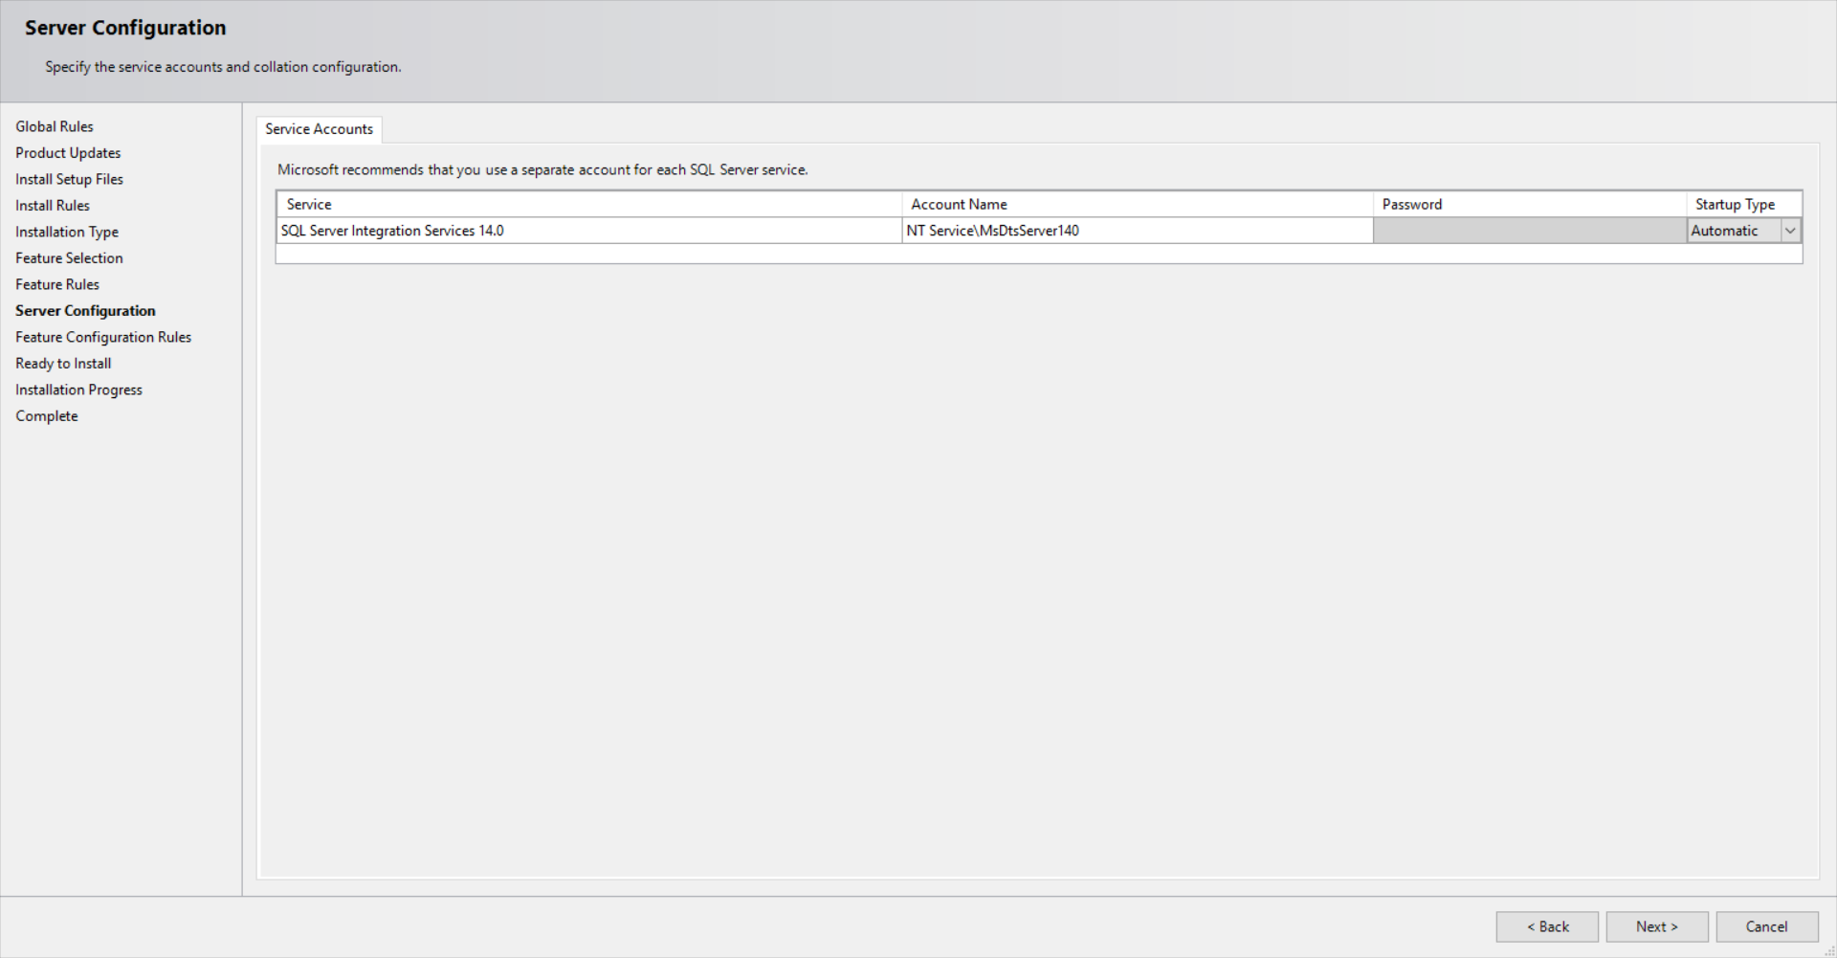

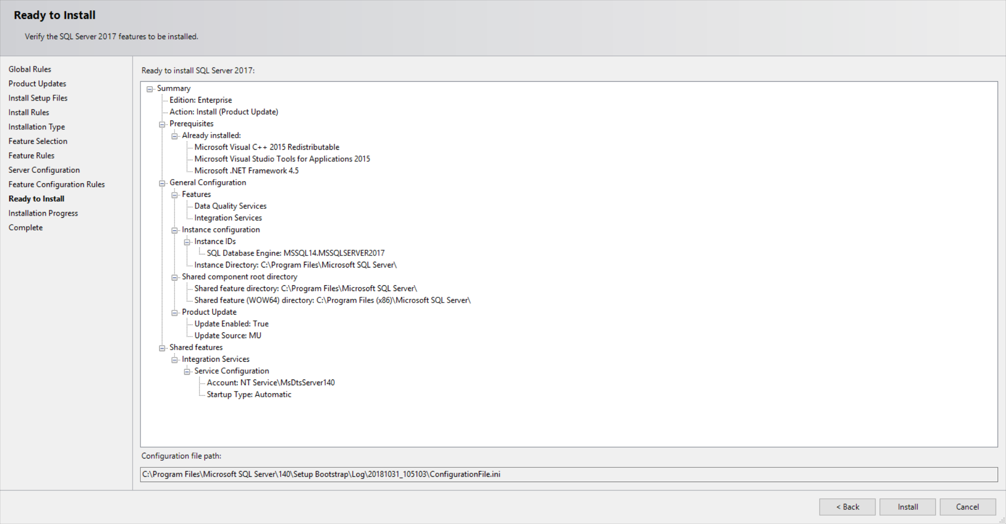

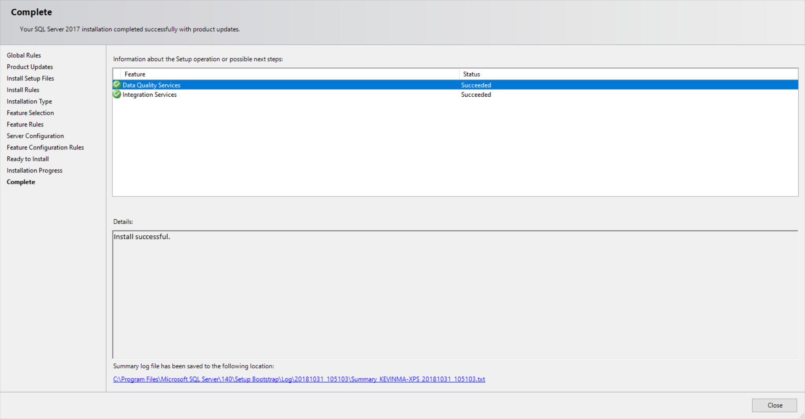

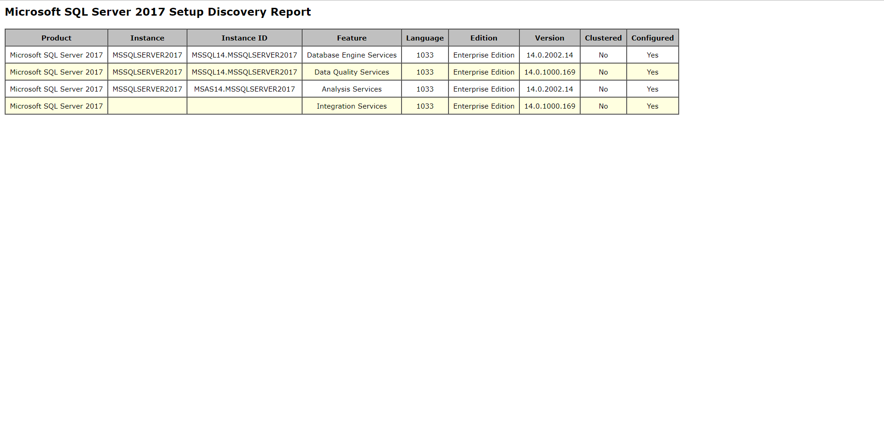

Also need

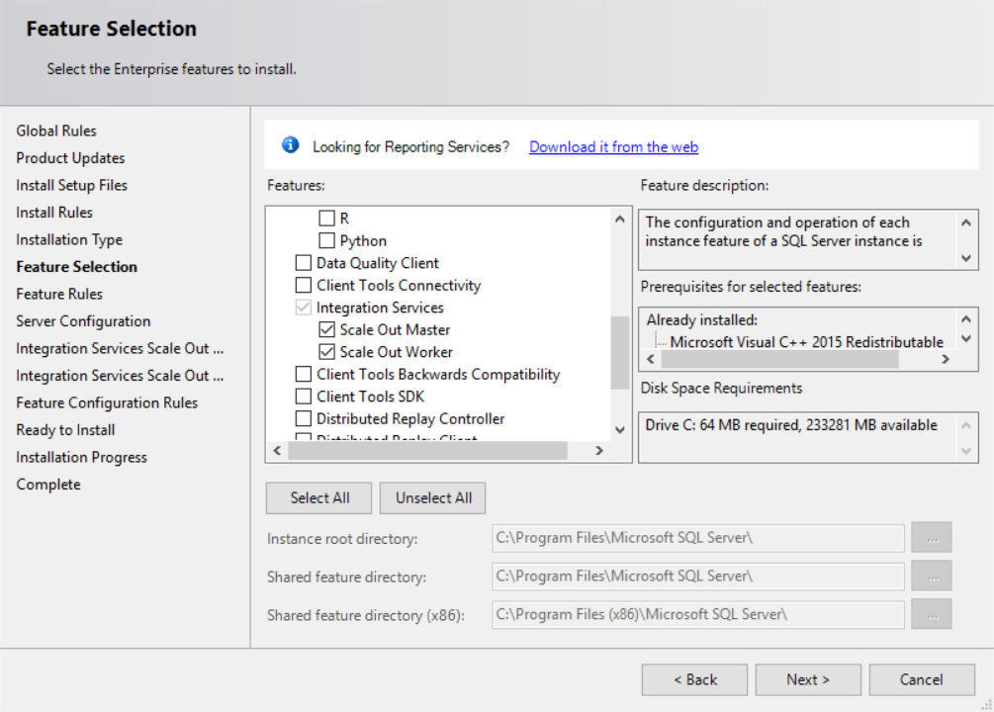

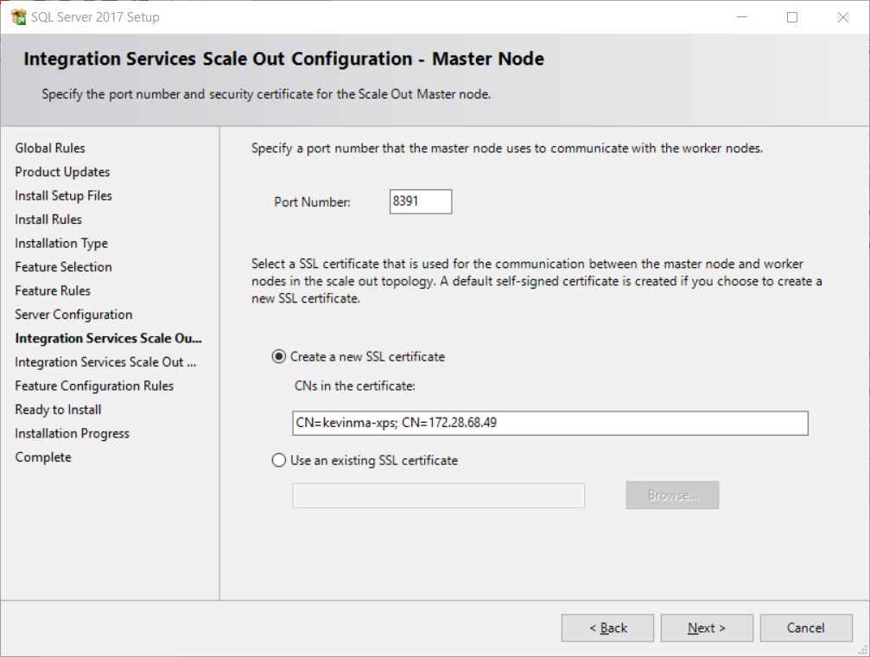

Instructions are terrible. Don’t tell us how to install pre-requisite software. 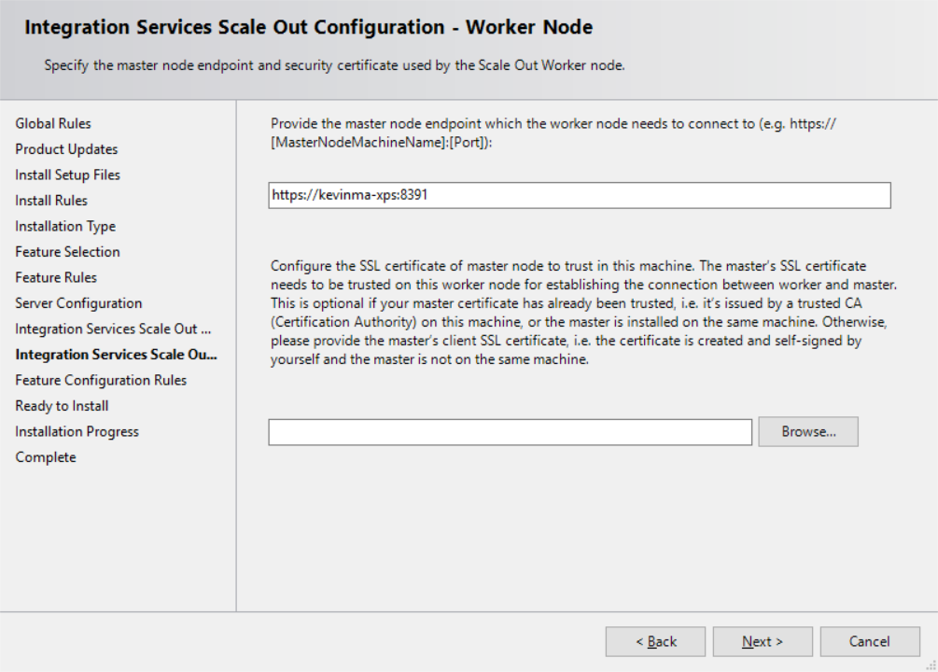

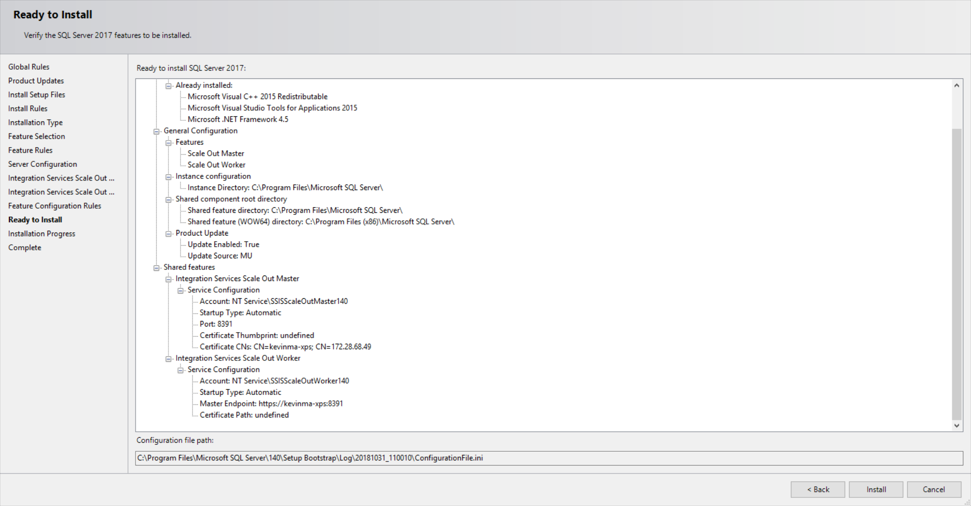

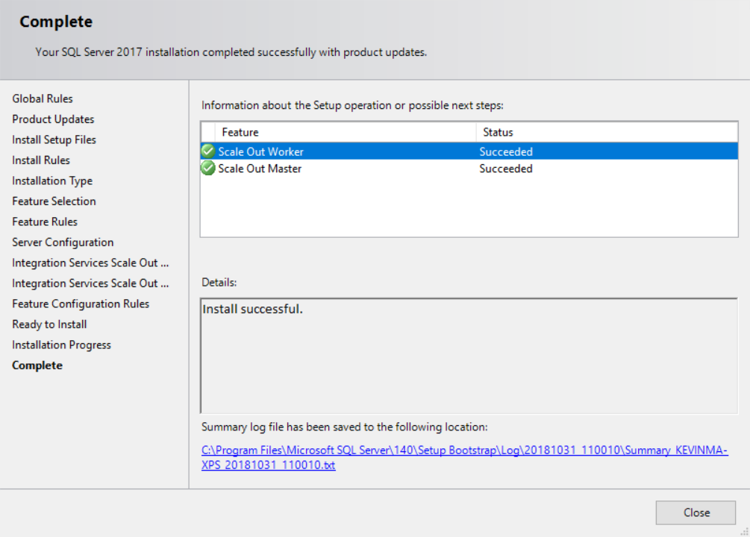

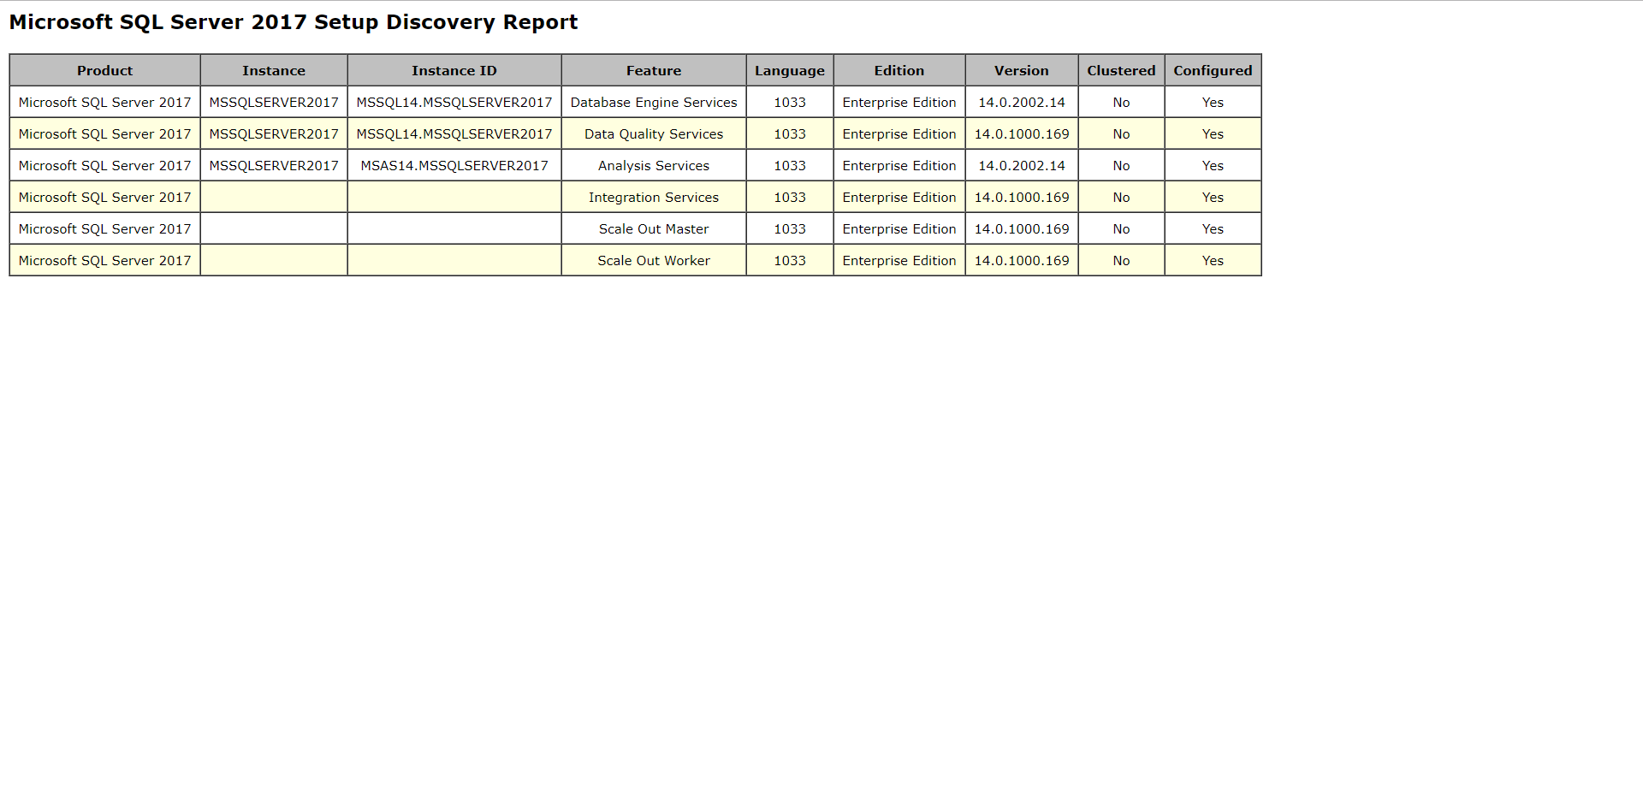

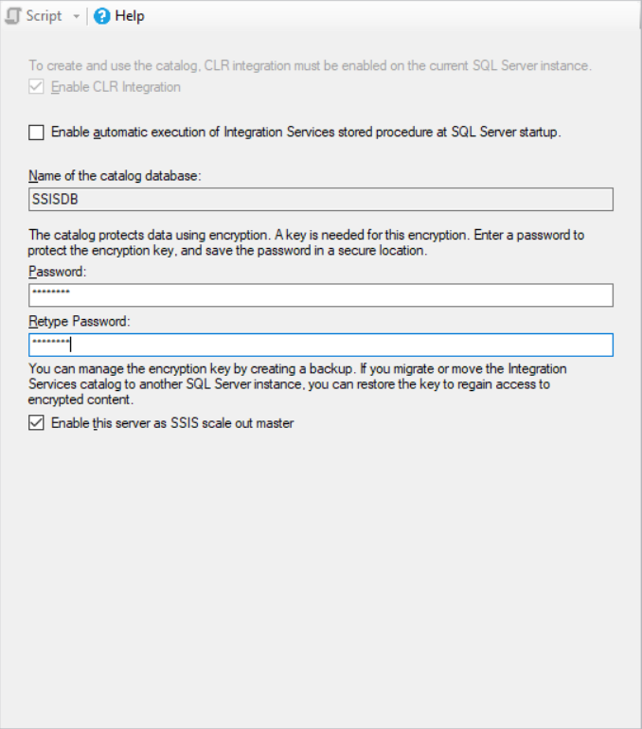

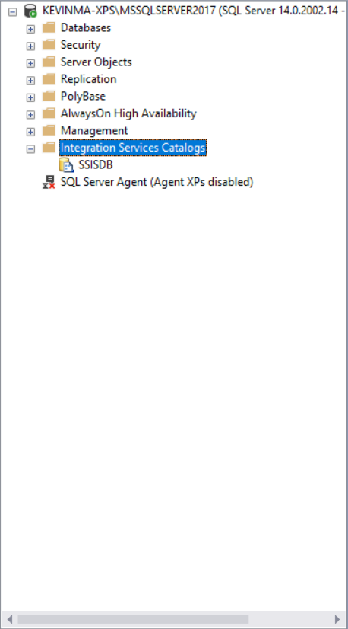

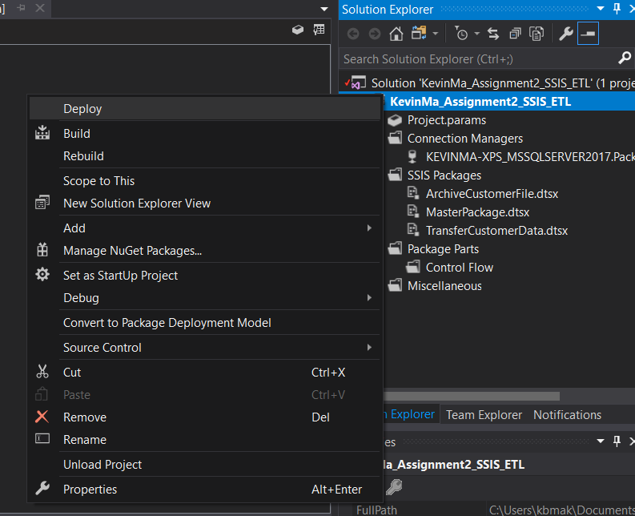

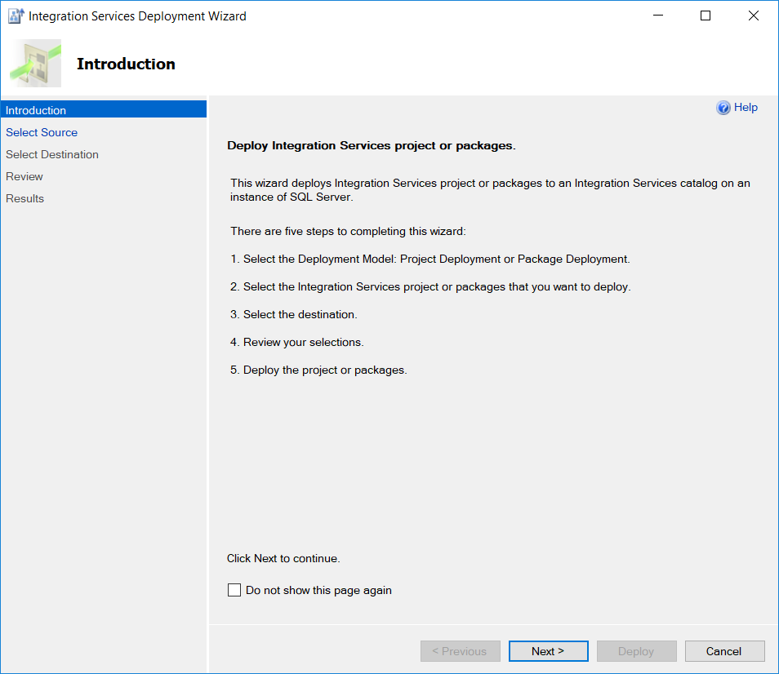

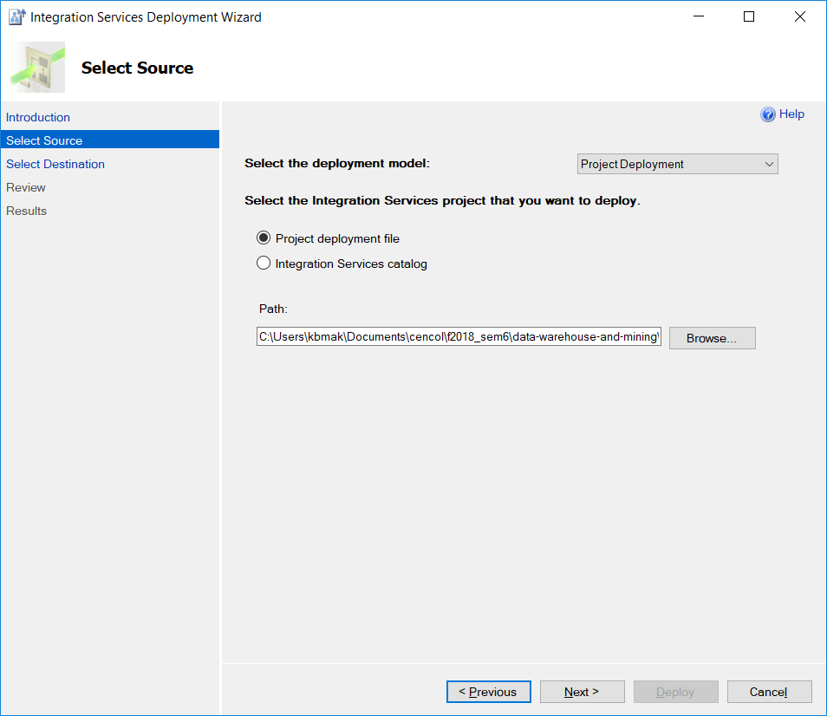

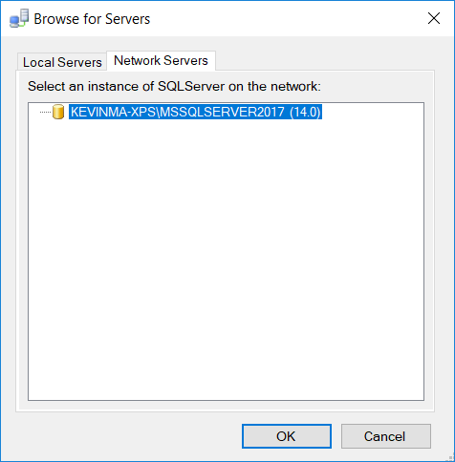

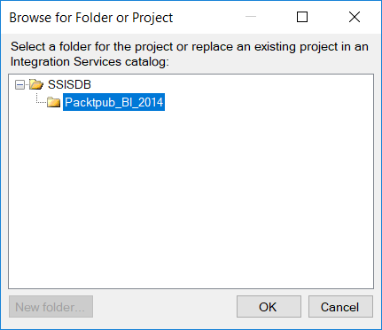

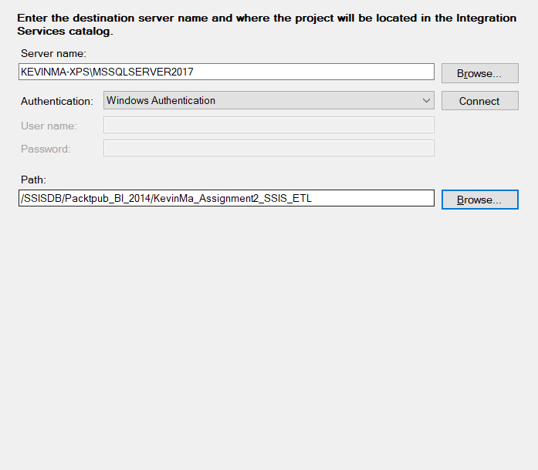

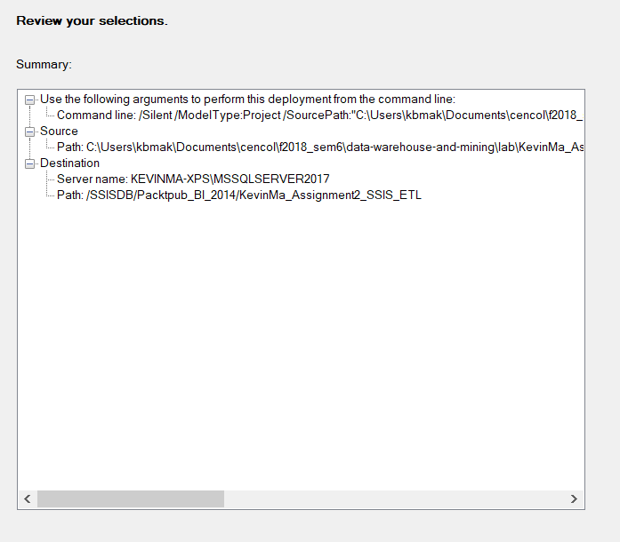

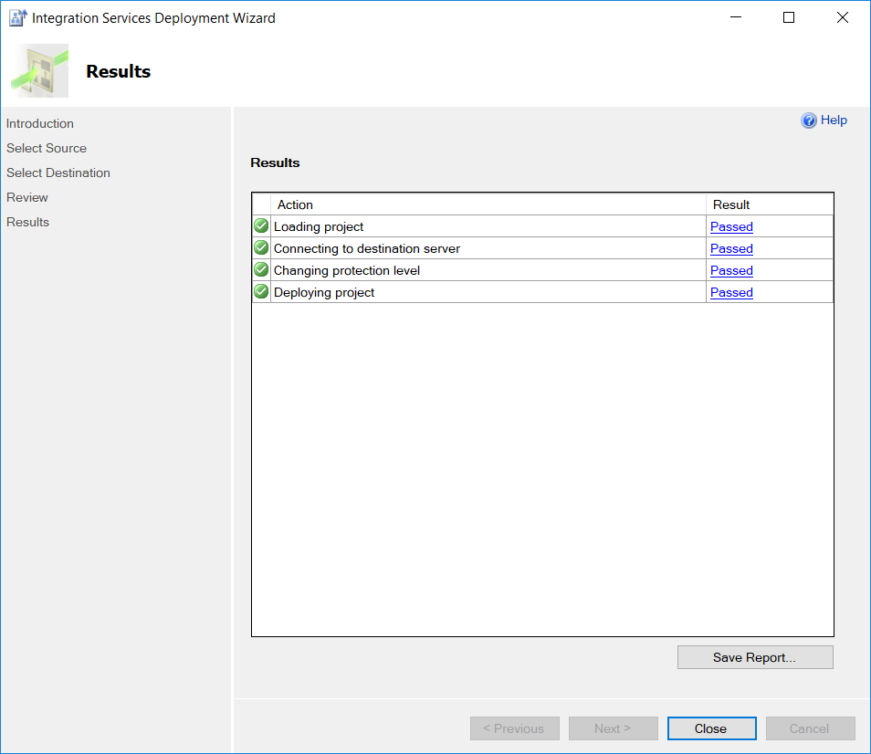

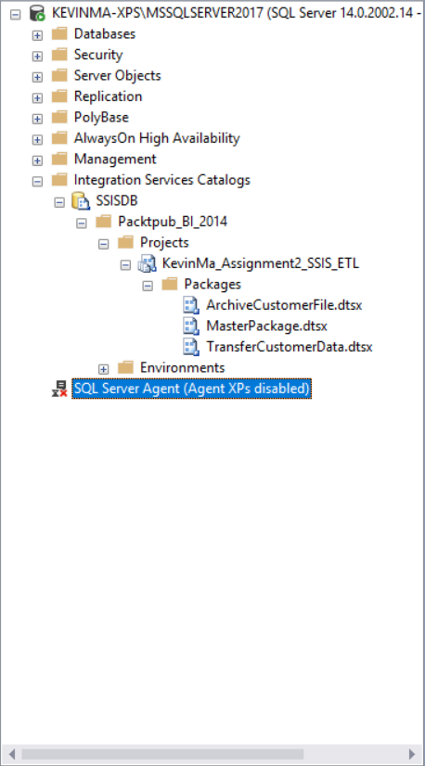

## What did we learn

# Time for action – executing an SSIS package from a catalog

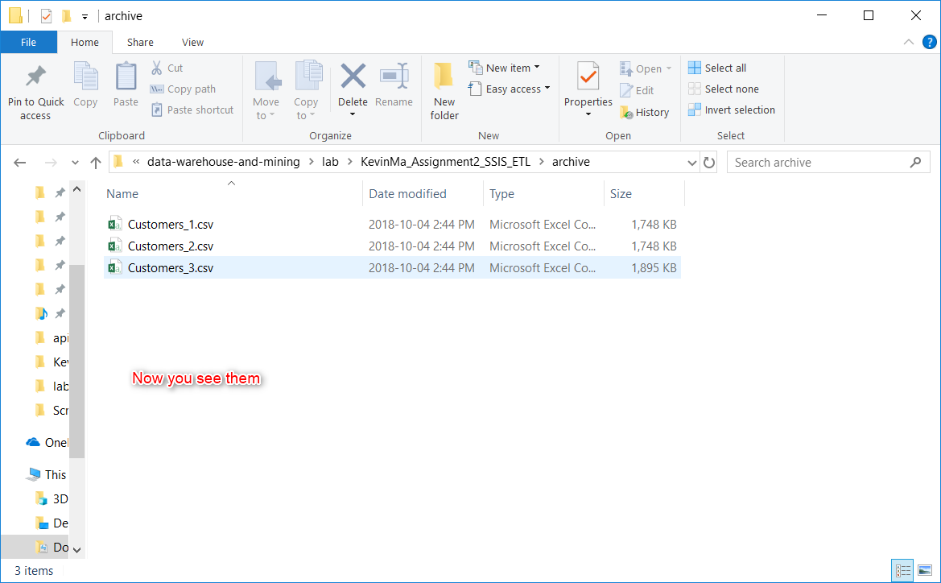

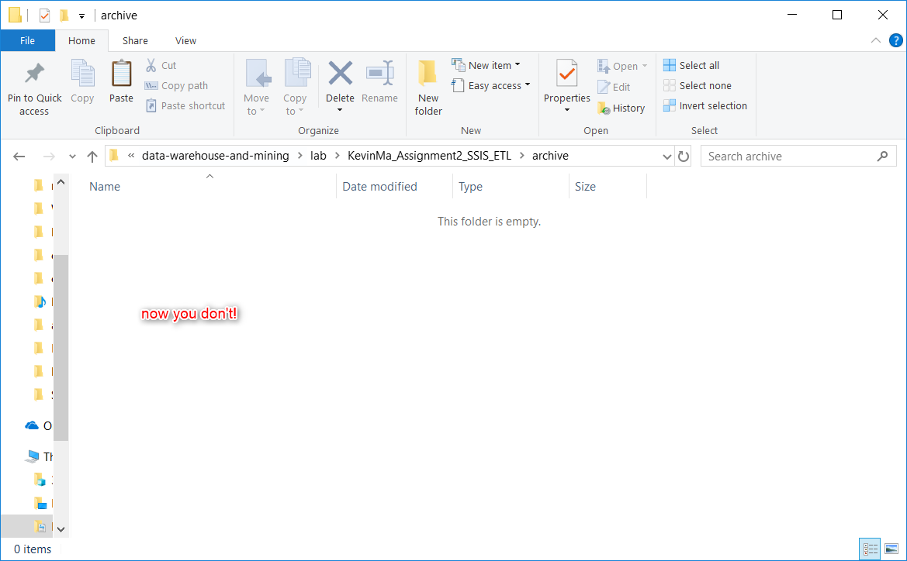

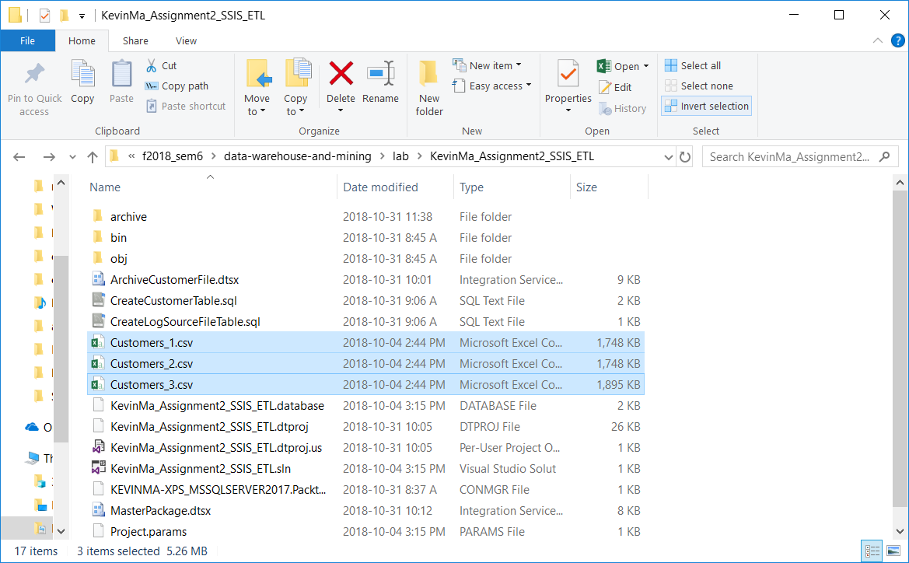

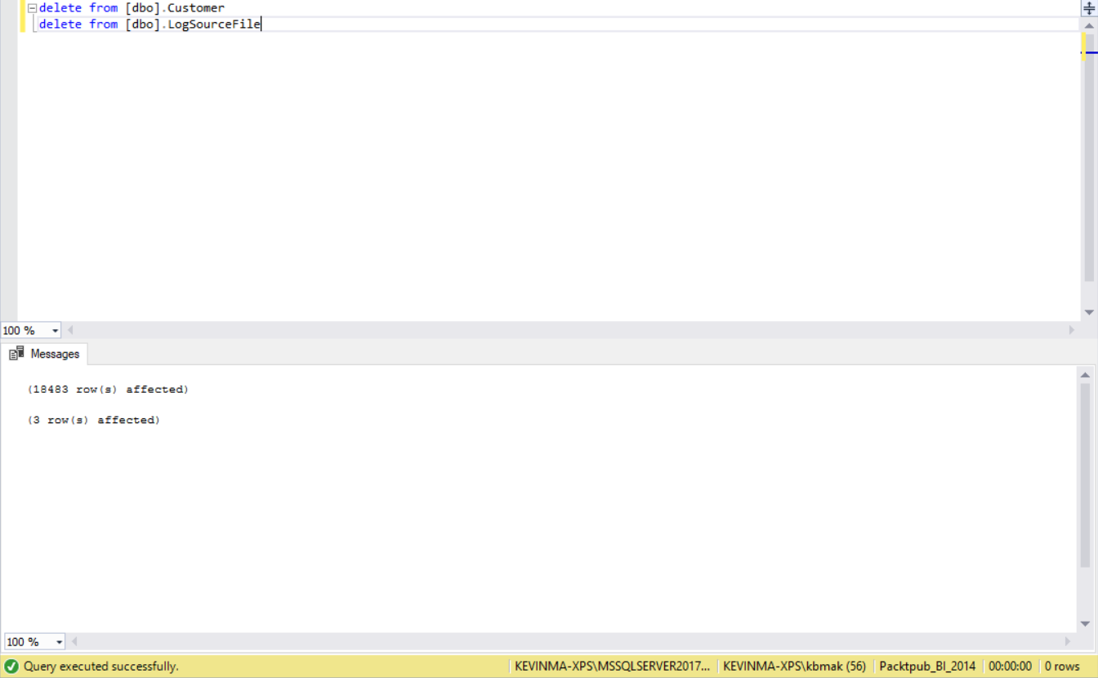

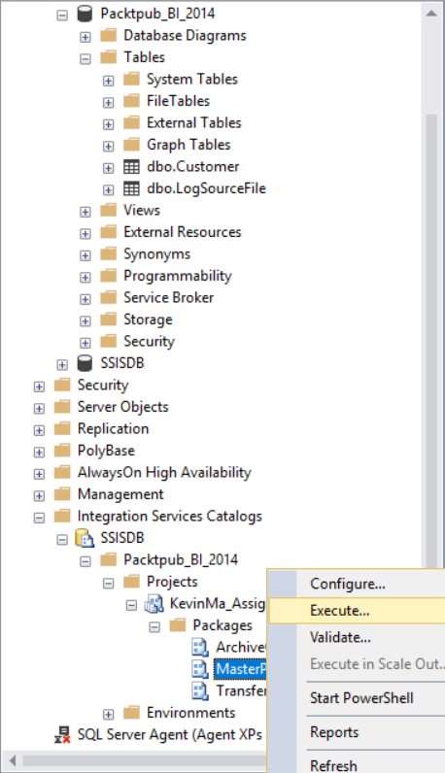

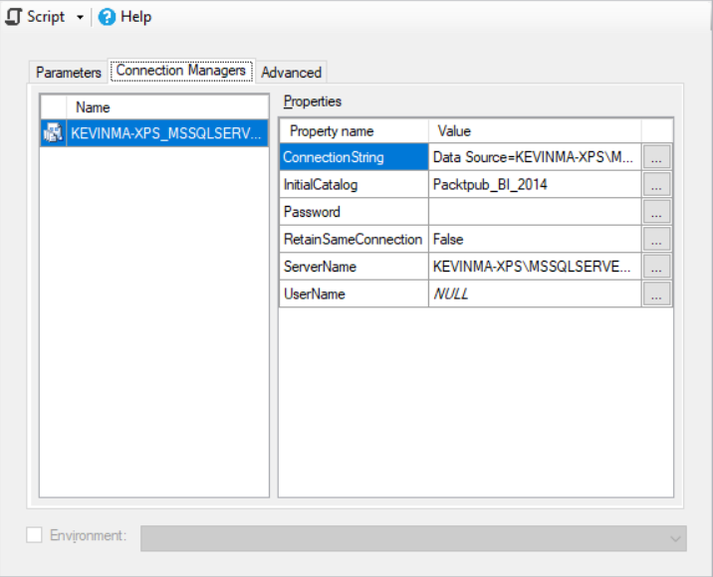

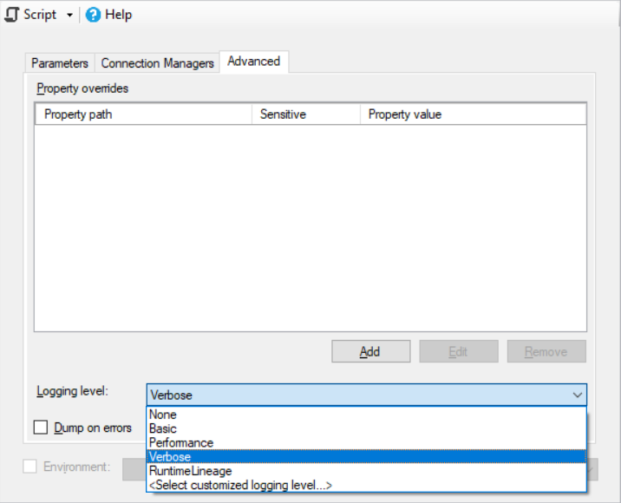

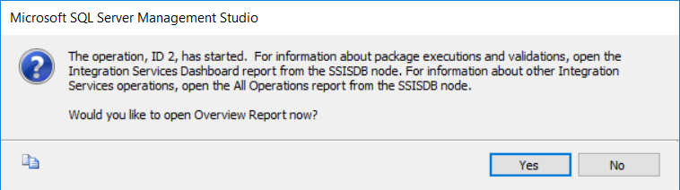

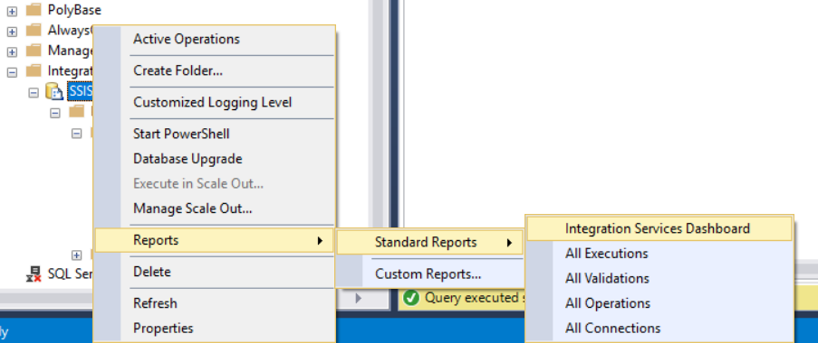

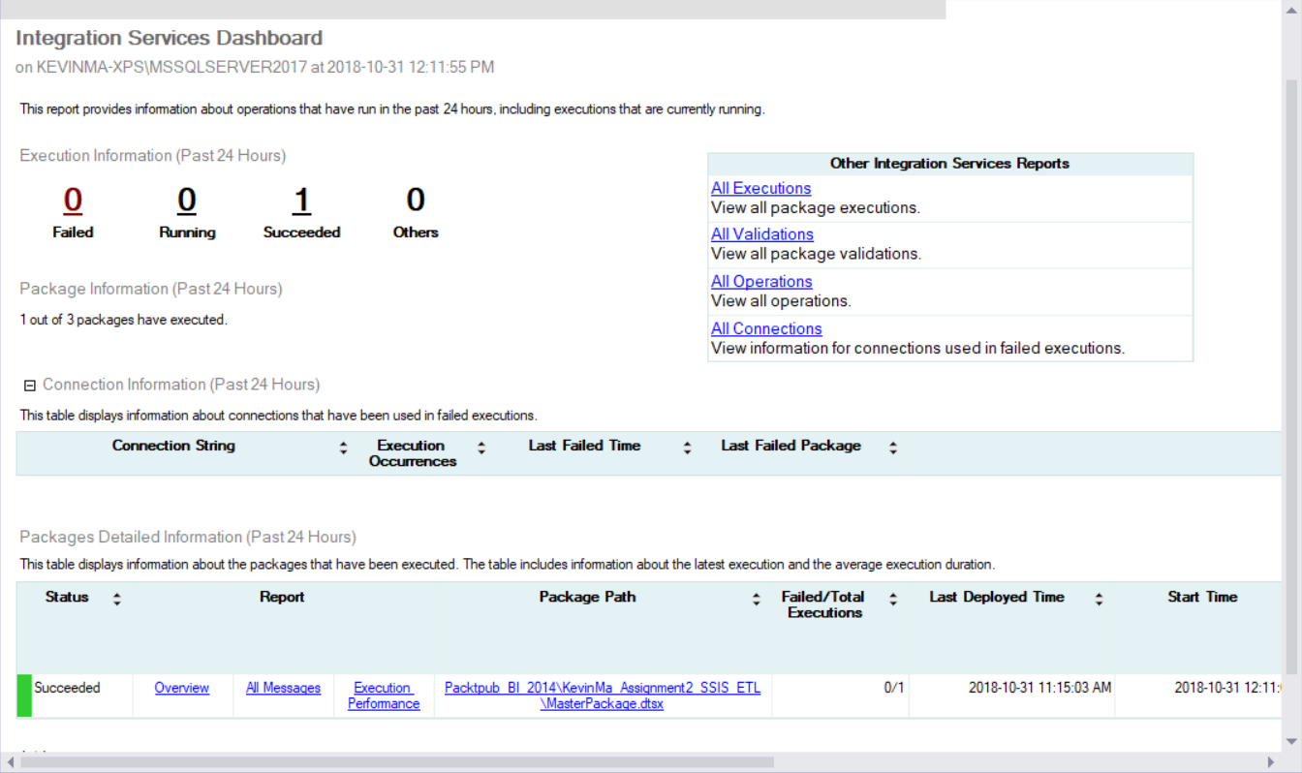

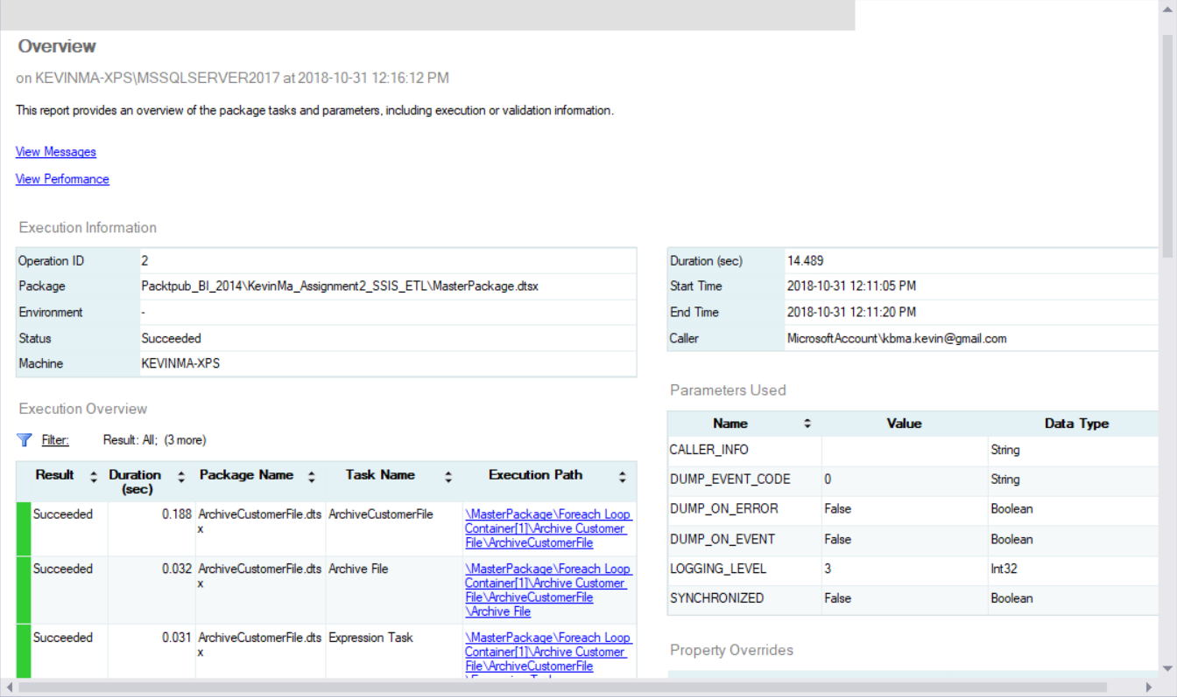

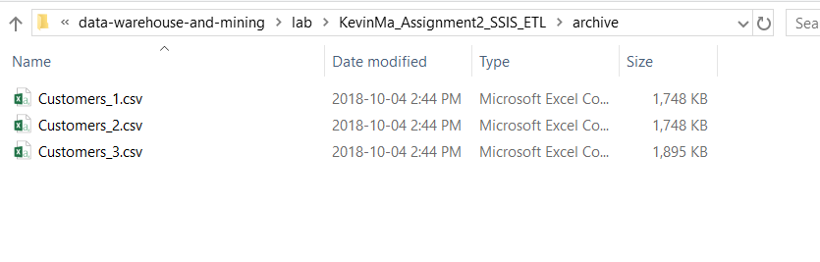

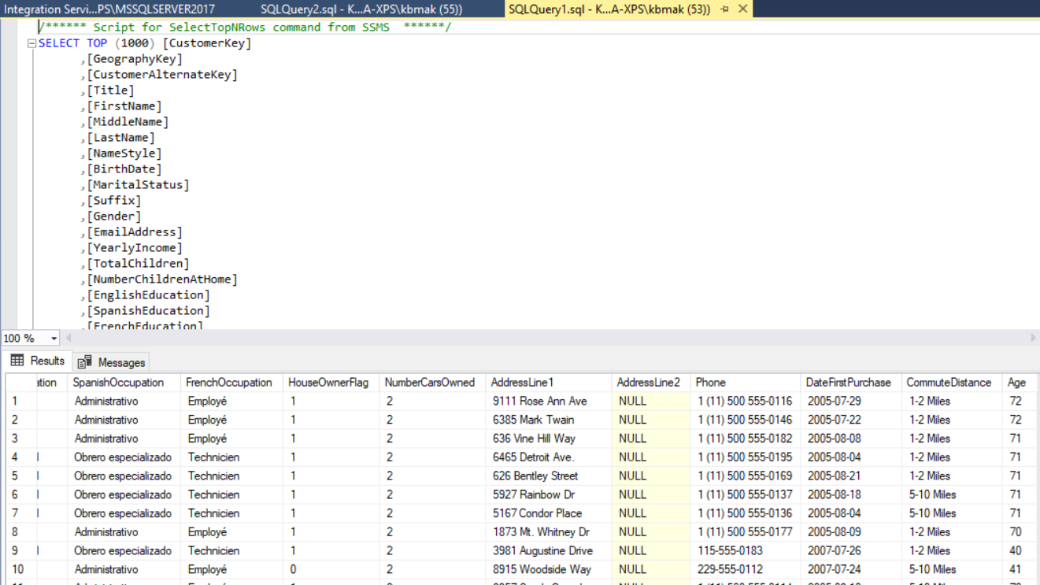

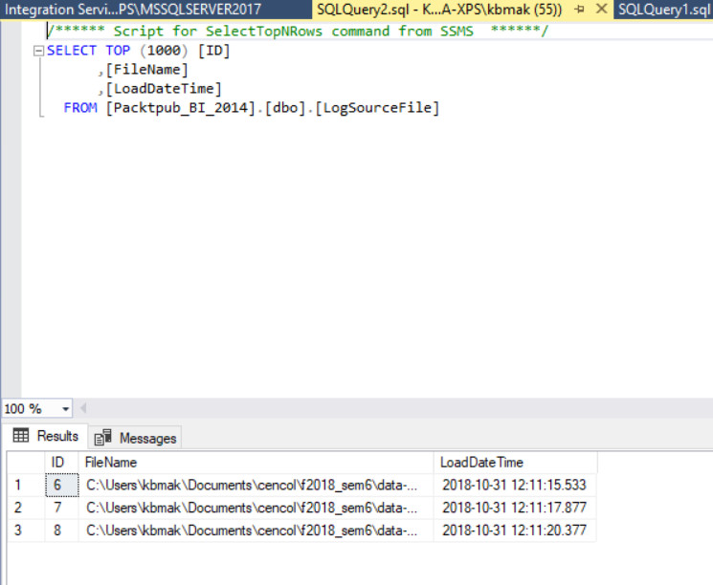

## What did we learn

# Conclusion:

Your conclusion should reflect your experience performing the ETL exercise: what

was easy, difficult and obscure.